ADVANCE DATABASE MANAGEMENT SYSTEM

**PRACTICAL 1:**

**Aim: Implementation of data partitioning using range partitioning**

**CODE:**

SQL> CREATE TABLE sales_range7

1. (salesman_id NUMBER(5),
2. salesman_name VARCHAR2(30),
3. sales_amount NUMBER(10),
4. sales_date DATE)
5. PARTITION BY RANGE(sales_date)
6. (
7. PARTITION sales_jan2000 VALUES LESS THAN(TO_DATE('31/01/2000','DD/MM/YYYY')),
8. PARTITION sales_feb2000 VALUES LESS THAN(TO_DATE('28/02/2000','DD/MM/YYYY')),
9. PARTITION sales_mar2000 VALUES LESS THAN(TO_DATE('31/03/2000','DD/MM/YYYY')), 11 PARTITION sales_apr2000 VALUES LESS THAN(TO_DATE('30/04/2000','DD/MM/YYYY'))

12 );

Table created.

SQL> insert into sales_range7

values(10,'Rohit',20000,to_date('20/01/2000','DD/MM/YYYY'));

1 row created.

SQL> insert into sales_range7

values(20,'Rahul',30000,to_date('27/02/2000','DD/MM/YYYY'));

1 row created.

SQL> insert into sales_range7

values(30,'Ramesh',50000,to_date('30/03/2000','DD/MM/YYYY'));

1 row created.

SQL> insert into sales_range7

values(40,'Siddharth',50000,to_date('30/03/2000','DD/MM/YYYY'));

1 row created.

SQL> insert into sales_range7

values(50,'Siddharth',60000,to_date('28/03/2000','DD/MM/YYYY'));

1 row created.

SQL> insert into sales_range7

values(60,'Satish',20000,to_date('27/02/2000','DD/MM/YYYY'));

1 row created.

SQL> insert into sales_range7

values(70,'Ramesh',10000,to_date('25/01/2000','DD/MM/YYYY'));

1 row created.

SQL> select*from sales_range7;

SALESMAN_ID SALESMAN_NAME SALES_AMOUNT SALES_DAT

----------- ------------------------------ ------------ --------- 10 Rohit 20000 20-JAN-00

70 Ramesh 10000 25-JAN-00

20 Rahul 30000 27-FEB-00

60 Satish 20000 27-FEB-00

30 Ramesh 50000 30-MAR-00

40 Siddharth 50000 30-MAR-00 50 Siddharth 60000 28-MAR-00

7 rows selected.

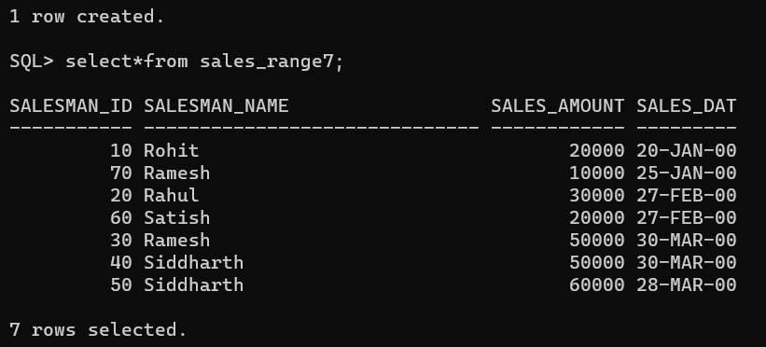

SQL> select * from sales_range7 partition(sales_jan2000);

SALESMAN_ID SALESMAN_NAME SALES_AMOUNT SALES_DAT

----------- ------------------------------ ------------ --------- 10 Rohit 20000 20-JAN-00

70 Ramesh 10000 25-JAN-00

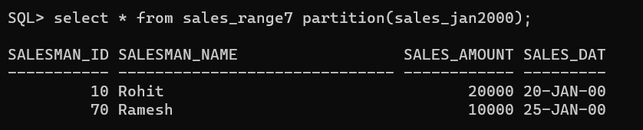

SQL> select * from sales_range7 partition(sales_feb2000);

SALESMAN_ID SALESMAN_NAME SALES_AMOUNT SALES_DAT

----------- ------------------------------ ------------ --------- 20 Rahul 30000 27-FEB-00

60 Satish 20000 27-FEB-00

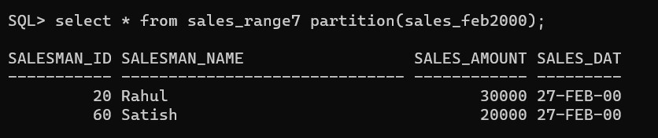

SQL> select * from sales_range7 partition(sales_mar2000);

SALESMAN_ID SALESMAN_NAME SALES_AMOUNT SALES_DAT

----------- ------------------------------ ------------ --------- 30 Ramesh 50000 30-MAR-00

40 Siddharth 50000 30-MAR-00 50 Siddharth 60000 28-MAR-00

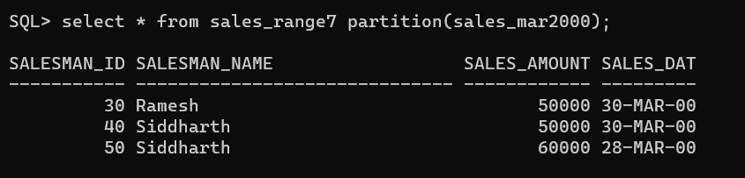

SQL> select * from sales_range7 partition(sales_apr2000);

no rows selected

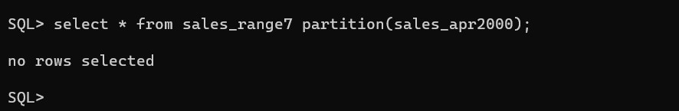

**PRACTICAL 2:**

**Aim: Implementation of data portioning using list partitioning**

**CODE:**

SQL> CREATE TABLE sales_list7

1. (salesman_id NUMBER(5),salesman_name VARCHAR(20),sales_state

VARCHAR(20),sales_amount NUMBER(10),sales_date DATE)

1. PARTITION BY LIST(sales_state)
2. (PARTITION sales_west VALUES('California','Hawaii'),
3. PARTITION sales_east VALUES('New York','Virginia','Florida'),
4. PARTITION sales_central VALUES('Texas','Illinios'),
5. PARTITION sales_other VALUES(DEFAULT));

Table created.

SQL> insert into sales_list7

values(1,'Siddharth','California',2000,to_date('12/10/2023','dd/mm/yyyy'));

1 row created.

SQL> insert into sales_list7

values(2,'Sahil','Hawaii',2000,to_date('14/10/2023','dd/mm/yyyy'));

1 row created.

SQL> insert into sales_list7 values(3,'Omkar','New

York',8000,to_date('14/10/2023','dd/mm/yyyy'));

1 row created.

SQL> insert into sales_list7

values(4,'Rahul','Texas',7000,to_date('13/10/2023','dd/mm/yyyy'));

1. row created.

SQL> select * from sales_list7;

SALESMAN_ID SALESMAN_NAME SALES_STATE SALES_AMOUNT SALES_DAT

----------- -------------------- -------------------- ------------ --------- 1 Siddharth California 2000 12-OCT-23

1. Sahil Hawaii 2000 14-OCT-23
2. Omkar New York 8000 14-OCT-23
3. Rahul Texas 7000 13-OCT-23

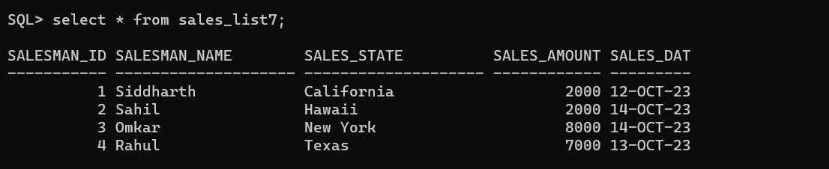

SQL> select * from sales_list7 partition(sales_east);

SALESMAN_ID SALESMAN_NAME SALES_STATE SALES_AMOUNT SALES_DAT

----------- -------------------- -------------------- ------------ --------- 3 Omkar New York 8000 14-OCT-23

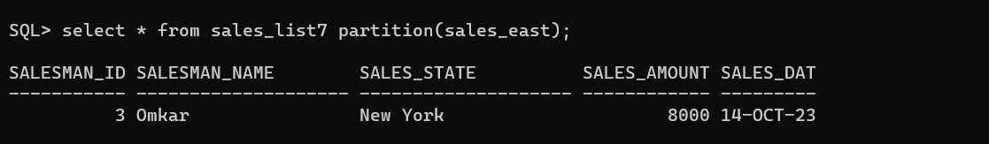

SQL> select * from sales_list7 partition(sales_west);

SALESMAN_ID SALESMAN_NAME SALES_STATE SALES_AMOUNT SALES_DAT

----------- -------------------- -------------------- ------------ --------- 1 Siddharth California 2000 12-OCT-23

2 Sahil Hawaii 2000 14-OCT-23

SQL>

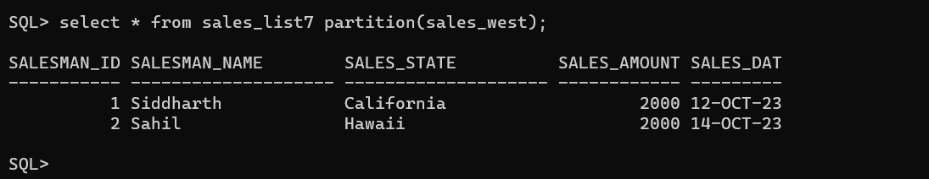

**PRACTICAL 3:**

**Aim: Implementation of Analytical Queries**

**CODE:**

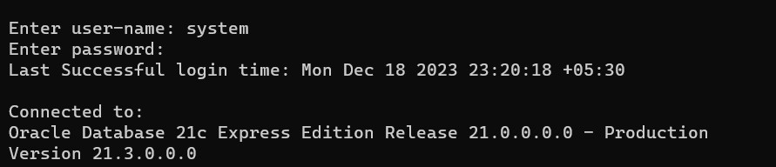

create table mcastudent(rollno number,name varchar(20),subject varchar(15),marks number);

Table created.

SQL> insert into mcastudent values(101,'charlie','adms',50);

1 row created.

SQL> insert into mcastudent values(102,’taylor ','adms',70);

1 row created.

SQL> insert into mcastudent values(103,'selena','adms',70);

1 row created.

SQL> insert into mcastudent values(104,'nick','adms',60);

1 row created.

SQL> select * from mcastudent;



**1)**

**Lowest**

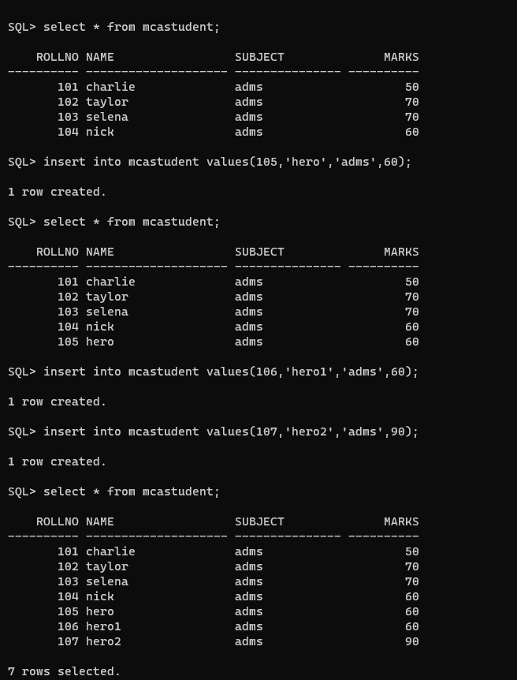

SQL> select rollno,name,subject,marks,min(marks) keep(dense_rank first order by marks) over (partition by subject) as "lowest" from mcastudent order by subject,marks;

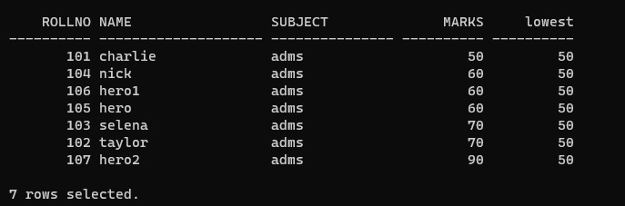

**2)Highest**

SQL> select rollno,name,subject,marks,max(marks) keep(dense_rank last order by marks)over (partition by subject) as "highest" from student order by subject,marks;

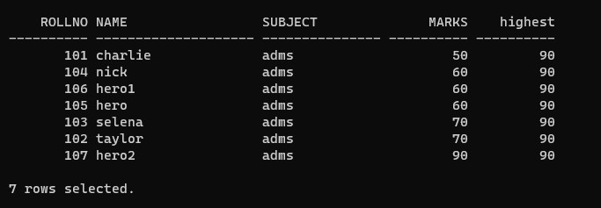

**3) Rank**

SQL> select rollno,name,subject,marks,rank() over( partition by subject order by marks) as "Rank" from mcastudent;

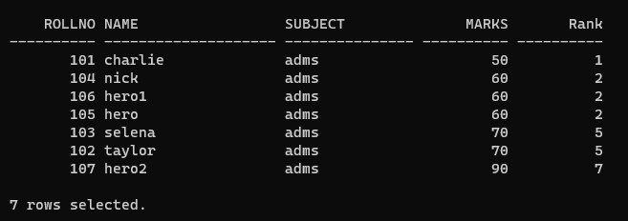

Dense Rank()

select rollno,name,subject,marks,dense_rank() over( partition by subject order by marks) as "Rank" from mcastudent;

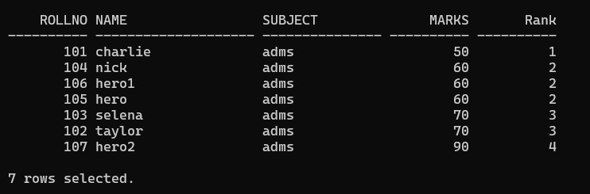

**PRACTICAL 4:**

**Aim: Implementation of Analytical Queries**

**Code**

**create a table employee1 with columns empid,empname,department,salary insert 6 records into the table and display lead and lag function**.

SQL> create table employee1(EMPID number,EMPname varchar(7),Department varchar(7),salary number,PRIMARY KEY(EMPID));

Table created.

SQL> insert into employee1 values(51,'rohan','IT',100000); 1 row created.

SQL> insert into employee1 values(52,'mohan','IT',200000); 1 row created.

SQL> insert into employee1 values(53,'rohit','IT',300000);

1 row created.

SQL> insert into employee1 values(54,'akshay','market',600000);

1 row created.

SQL> insert into employee1 values(55,'jay','market',500000); 1 row created.

SQL> insert into employee1 values(56,'suraj','finance',500000); 1 row created.

SQL> insert into employee1 values(57,'siddhth','finance',600000);

1 row created.

SQL> select * from employee1;

EMPID EMPNAME DEPARTM SALARY

---------- ------- ------- ----------

1. rohan IT 100000
2. mohan IT 200000
3. rohit IT 300000
4. akshay market 600000
5. jay market 500000
6. suraj finance 500000
7. siddhth finance 600000

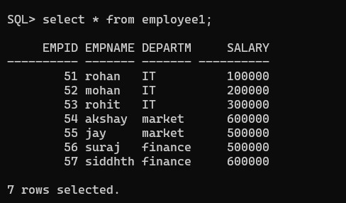

SQL> select empid,empname,department,salary,lag(salary,1,0) over(partition by department order by salary)as "previous" from employee1;

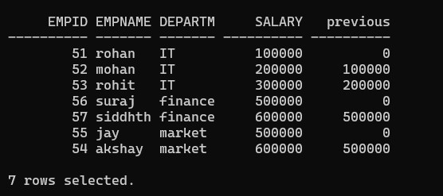

SQL> select empid,empname,department,salary,lead(salary,1,0) over(partition by department order by salary)as "next salary" from employee1;

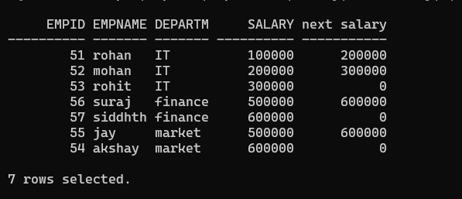

**5)Cube:-**

SQL> select rollno,subject,SUM(marks)from mcastudent group by cube(rollno,subject)order by rollno,subject;

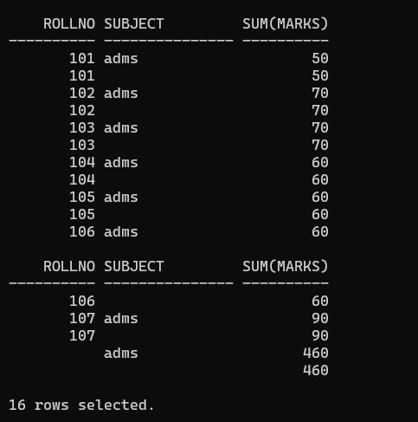

6)Roll Up:-

SQL> select rollno,subject,SUM(marks)from mcastudent group by rollup(rollno,subject)order by rollno,subject;

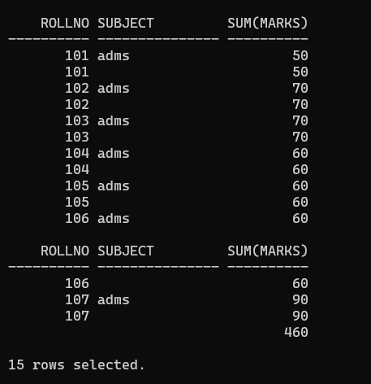

**PRACTICAL 5:**

**Aim: Implementation of ordbms(Abstract data type)**

**CODE:**

SQL> create type type_Sidd As object(fname varchar(20),mname varchar(20),lname varchar(20))

2 /

Type created.

SQL> create type type_Sidd_address As object(street varchar(20),city varchar(20),pincode number(20))

2 /

Type created.

SQL> create table table7(cid number(5) primary key,cname type_Sidd,cadd type_Sidd_address,cphno number(10));

Table created.

SQL> insert into table7

values(1,type_Sidd('Rahul','B','C'),type_Sidd_address('Thane','Mumbai',400052),65431145);

1 row created.

SQL> insert into table7

values(2,type_Sidd('Rohit','F','M'),type_Sidd_address('Bhandup','Mumbai',400152),6543114

5);

1 row created.

SQL> insert into table7

values(3,type_Sidd('Rohit1','F','M'),type_Sidd_address('Thane','Mumbai',400052),65431145)

;

1 row created.

SQL> select * from table7;

CID

----------

CNAME(FNAME, MNAME, LNAME)

--------------------------------------------------------------------------------

CADD(STREET, CITY, PINCODE)

-------------------------------------------------------------------------------- CPHNO ---------- 1

TYPE_SIDD('Rahul', 'B', 'C')

TYPE_SIDD_ADDRESS('Thane', 'Mumbai', 400052)

65431145

CID

----------

CNAME(FNAME, MNAME, LNAME)

--------------------------------------------------------------------------------

CADD(STREET, CITY, PINCODE)

-------------------------------------------------------------------------------- CPHNO ---------- 2

TYPE_SIDD('Rohit', 'F', 'M')

TYPE_SIDD_ADDRESS('Bhandup', 'Mumbai', 400152)

65431145

CID

----------

CNAME(FNAME, MNAME, LNAME)

--------------------------------------------------------------------------------

CADD(STREET, CITY, PINCODE)

-------------------------------------------------------------------------------- CPHNO ---------- 3

TYPE_SIDD('Rohit1', 'F', 'M')

TYPE_SIDD_ADDRESS('Thane', 'Mumbai', 400052)

65431145

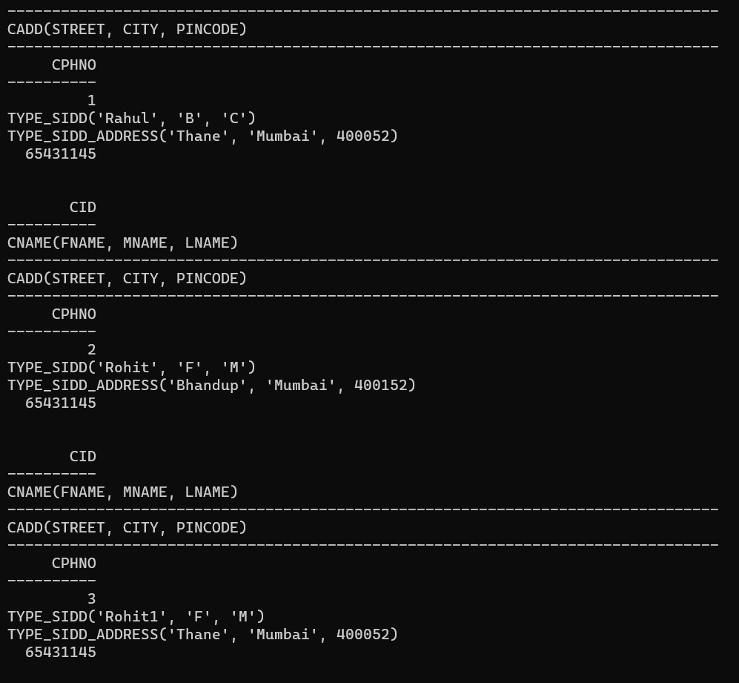

**PRACTICAL 6:**

**Aim: Implementation of Extract transformation with Pentaho**

1. **Table Input**

1)input folder→drag & drop→table input

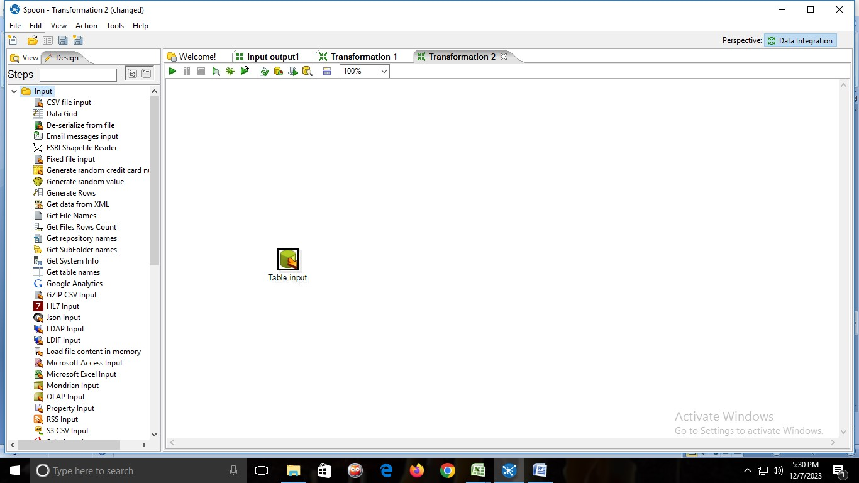

2)New→connection name

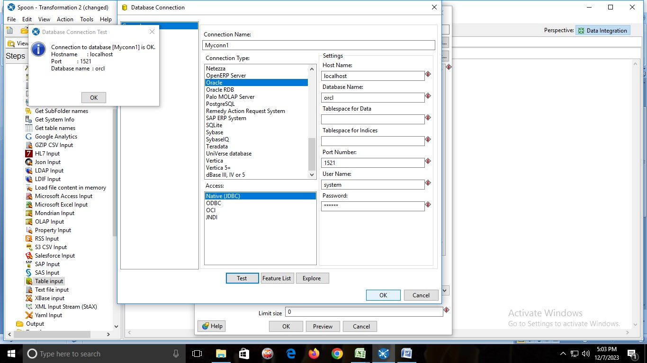

Click on→GET SQL SELECT STATEMENT→and select the table→then click on preview .

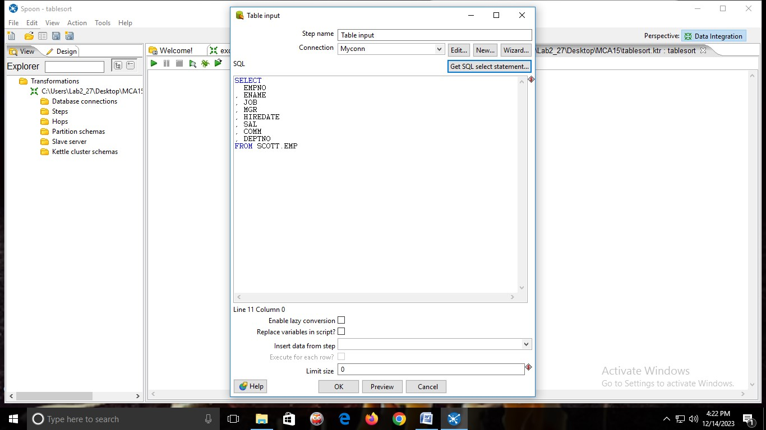

→Preview table

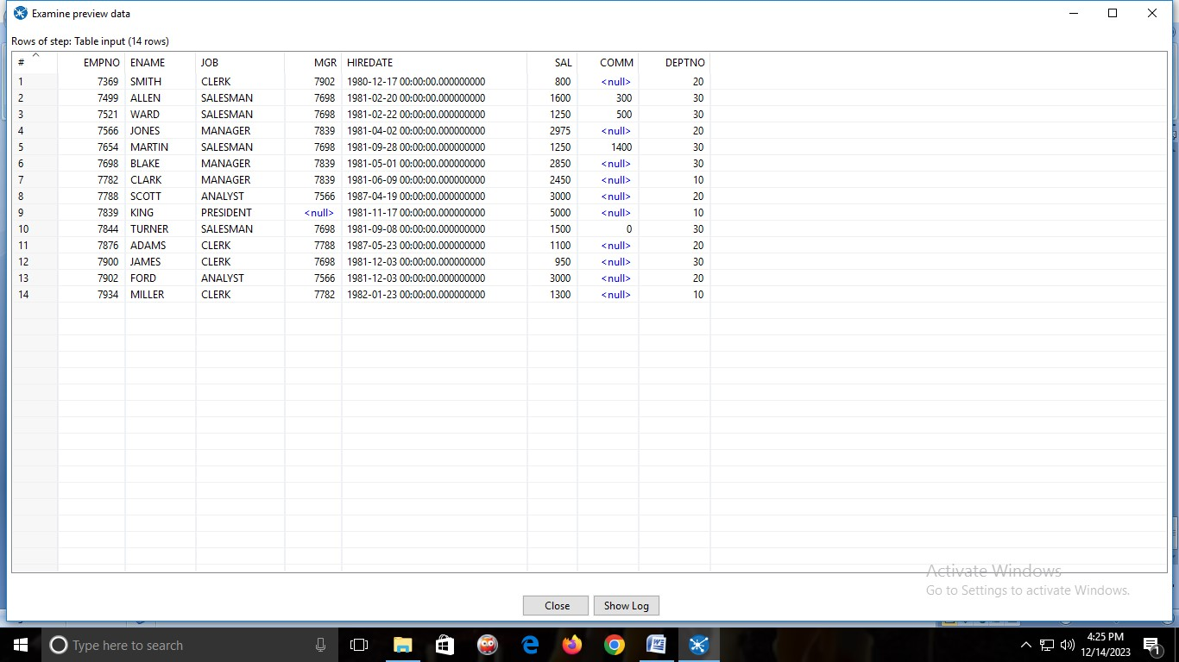

1. **Excel Input**

1) From input folder→drag & drop→ MICROSOFT EXCEL INPUT

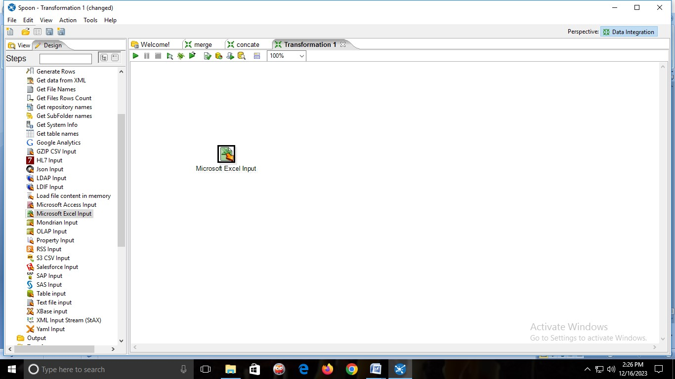

→Double click on it and add the Excel sheet.

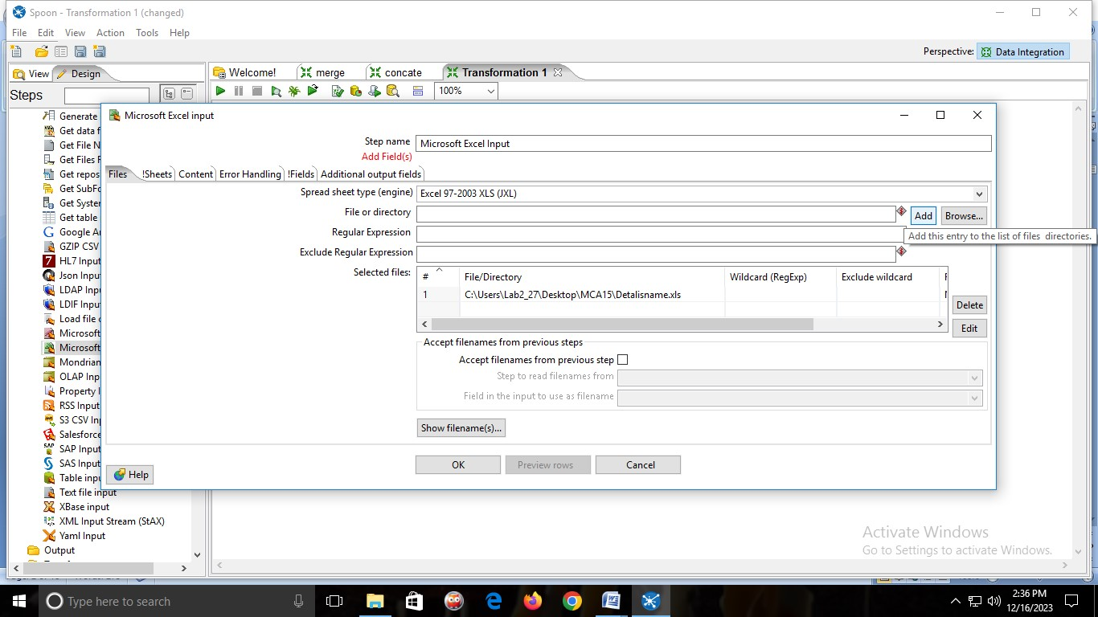

→click on get fields from header row

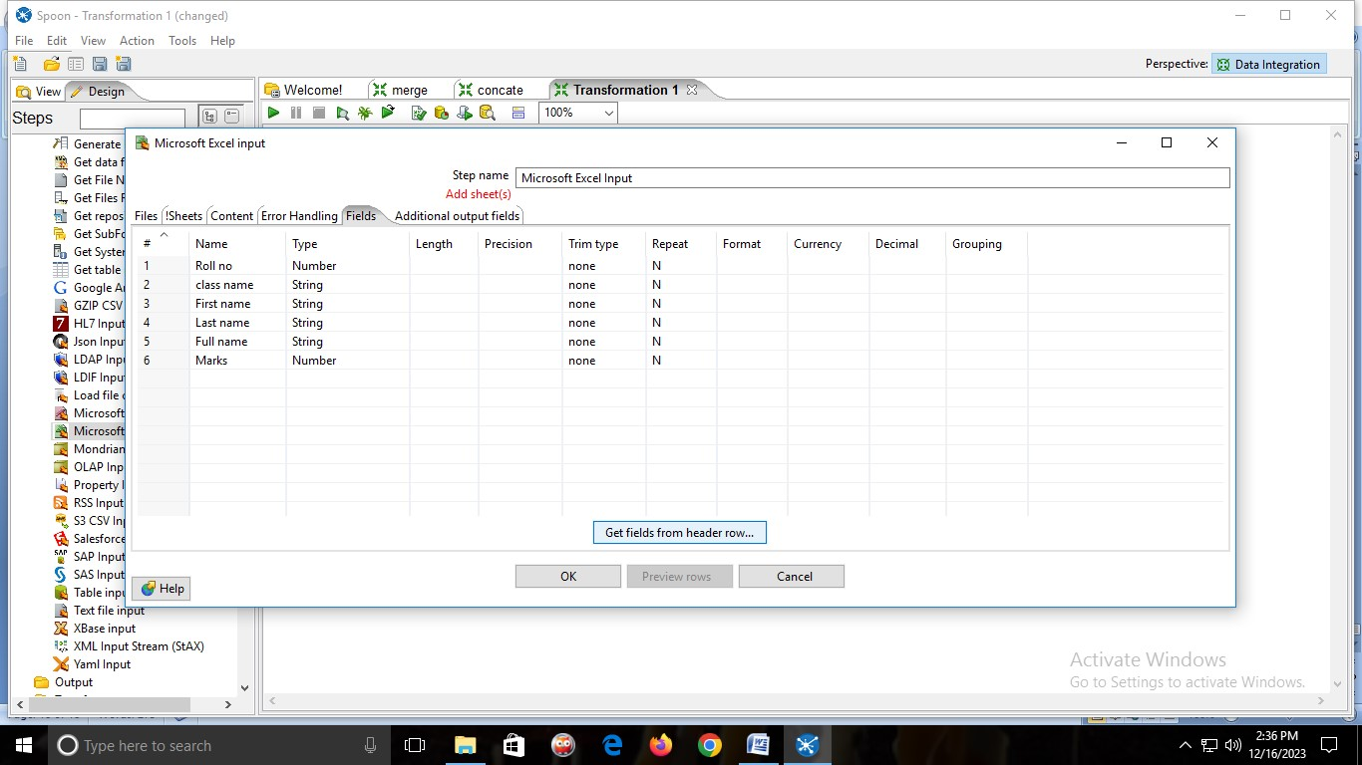

→then click on sheets→click on get sheetname→add sheet1→ok

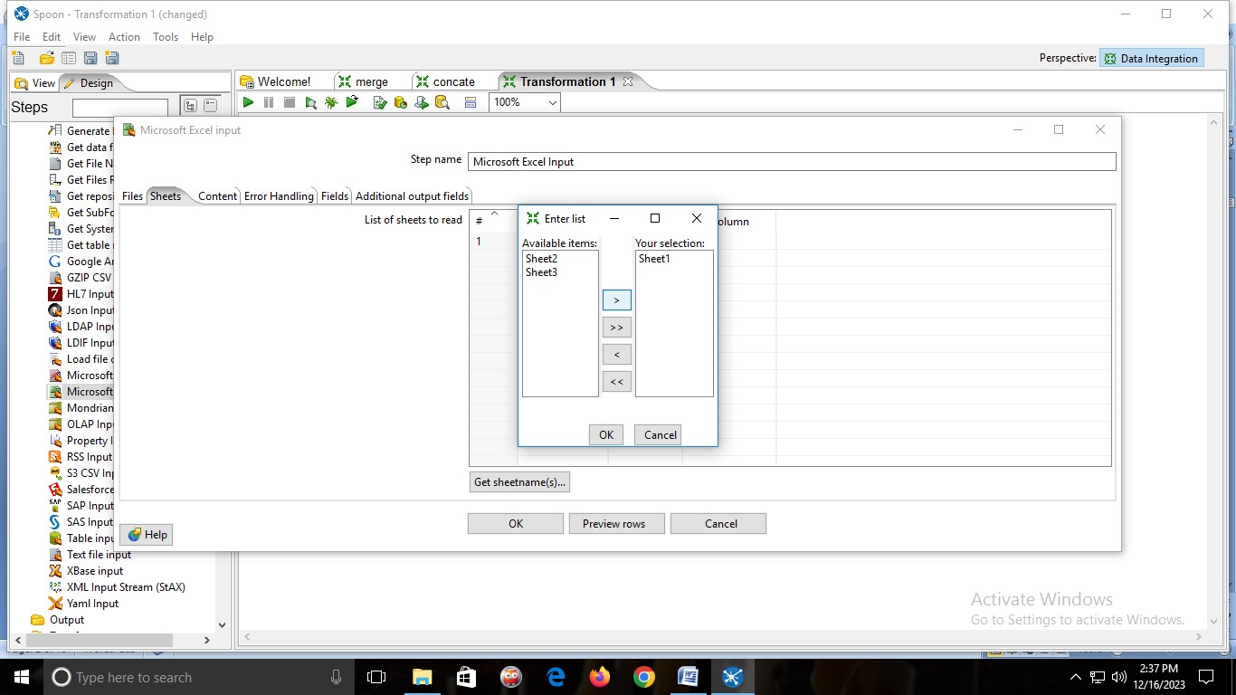

→click on Preview rows→Ok

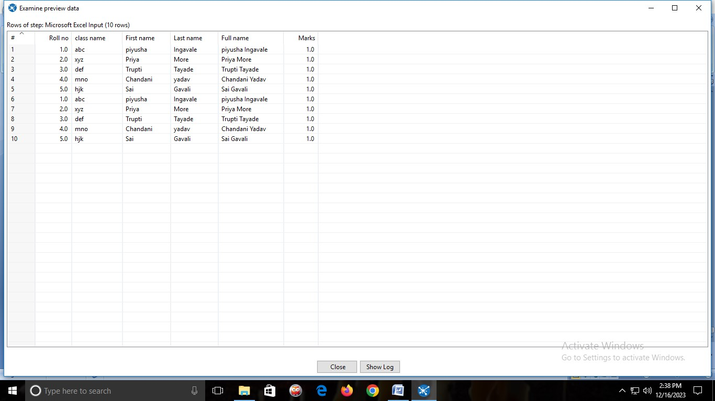

1. **Calculator**

1)create an Excel file

2)In Pentaho click on transformation .

3)In design →input folder→ drag & drop → Microsoft Excel Input →double click on it→browse the excel file→add→fields→

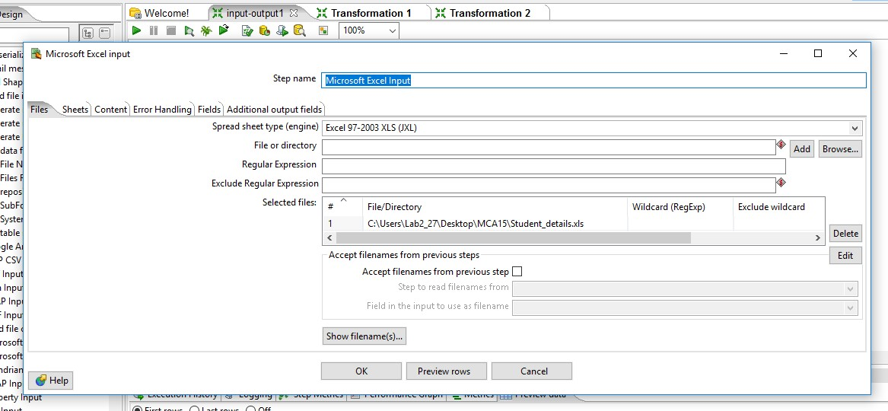

→click on get fields from header row

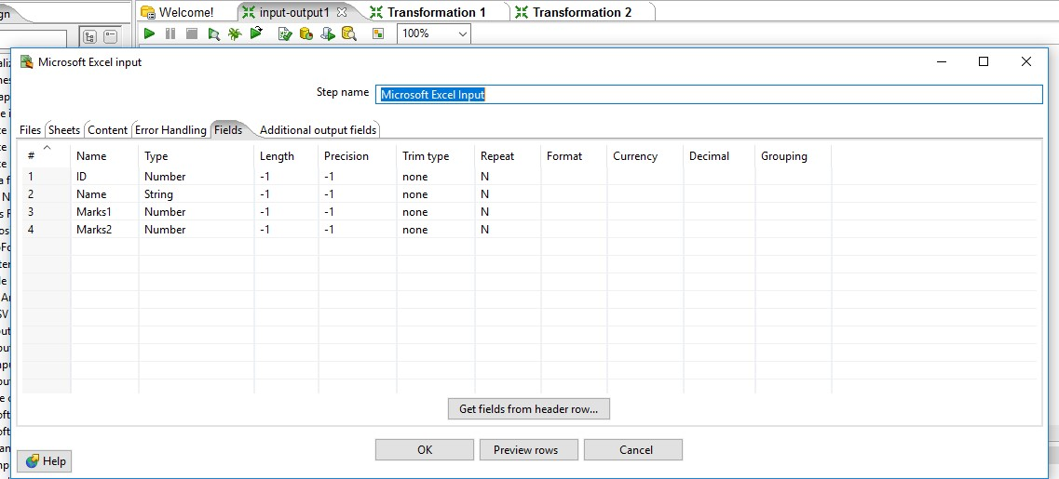

→then click on sheets→click on get sheetname→add sheet1→ok

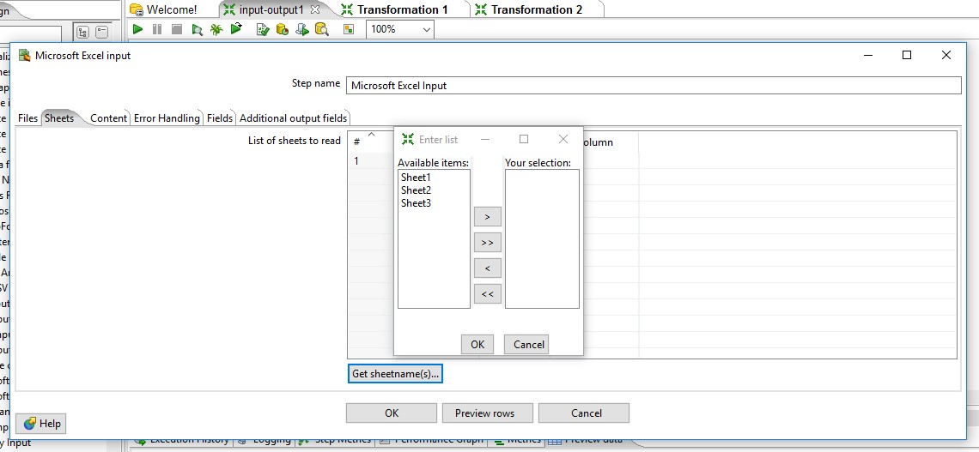

→click on Preview rows→Ok

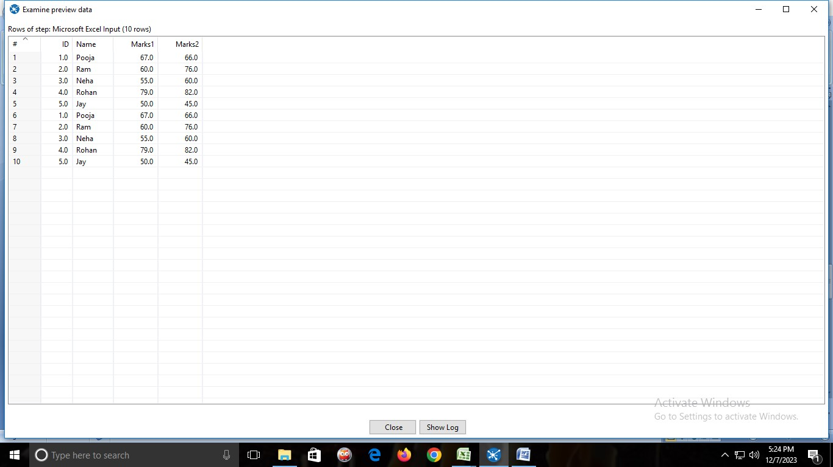

4)In transform folder →drag & drop →calculator→double click and details as follow→click Ok

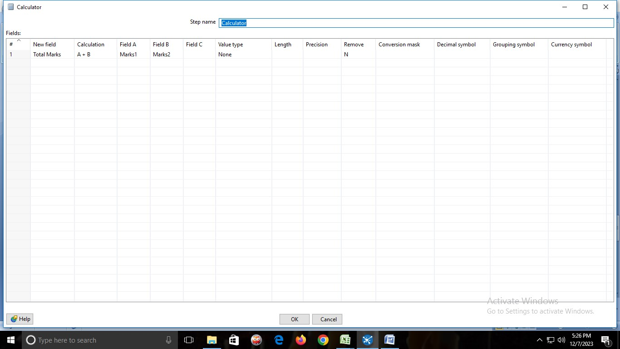

5)In Output folder→drag & drop→Microsoft Excel Output→double click→fields→get fields→OK

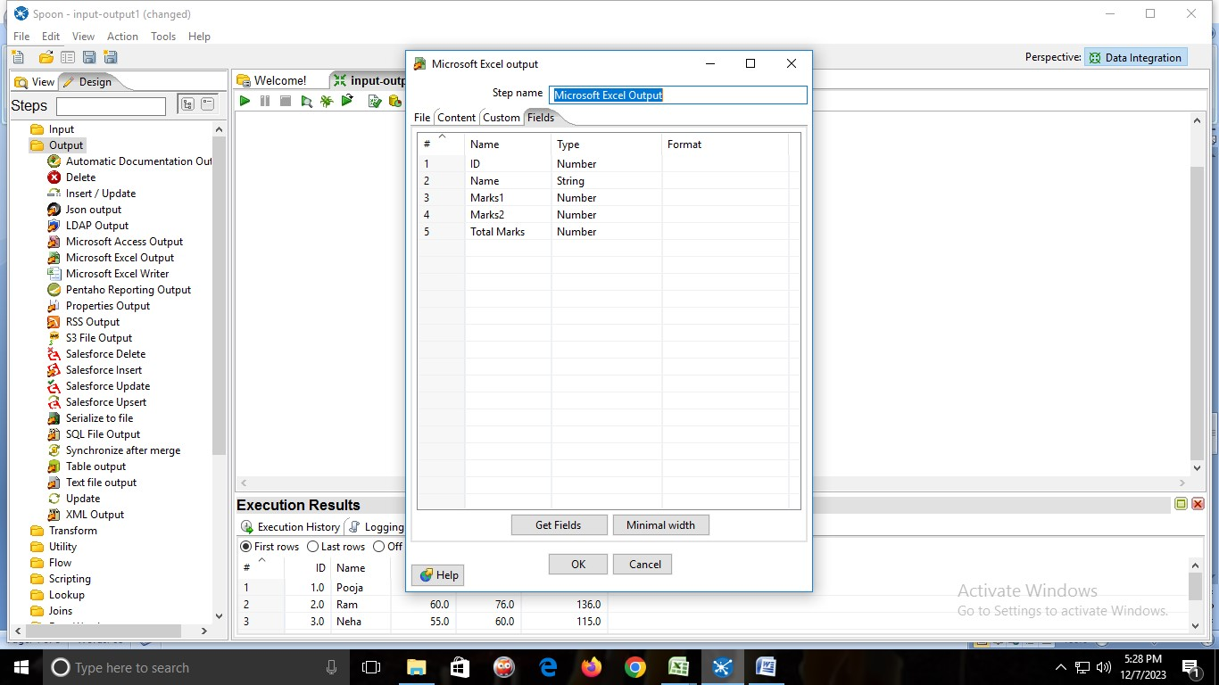

**OUTPUT:**

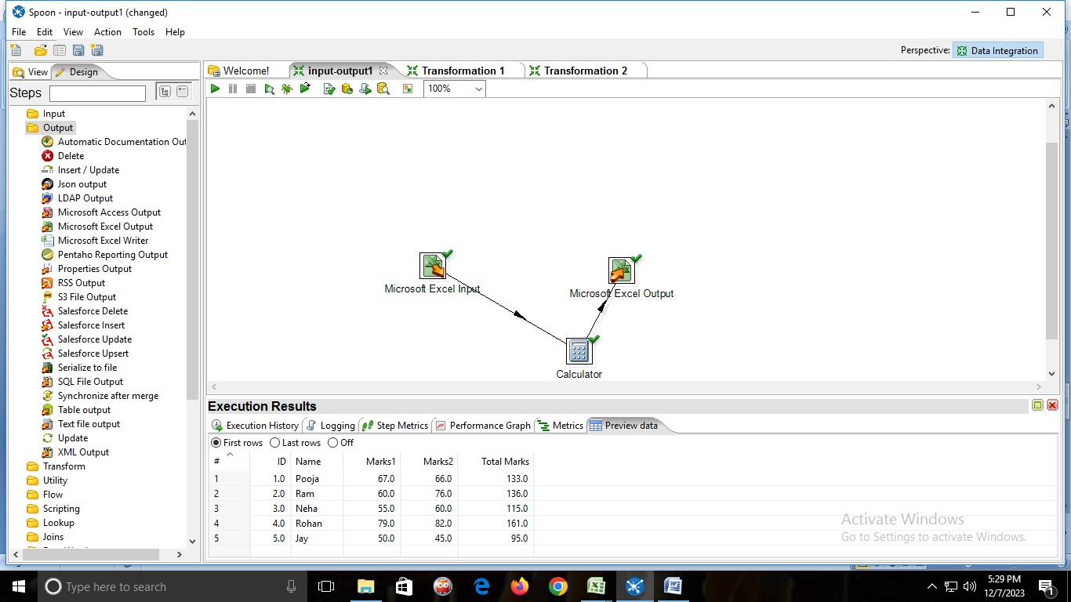

1. **Sequence String Operation**

1)create an Excel sheet with the fields firstname,lastname,fullname,rollno,marks

2)From input folder→drag & drop→ MICROSOFT EXCEL INPUT



→Double click on it and add the Excel sheet.



→click on get fields from header row



→then click on sheets→click on get sheetname→add sheet1→ok



→click on Preview rows→Ok



3)From Transform Folder→drag & drop→STRING OPERATIONS→and connect MICROSOFT EXCEL INPUT to STRING OPERATIONS.

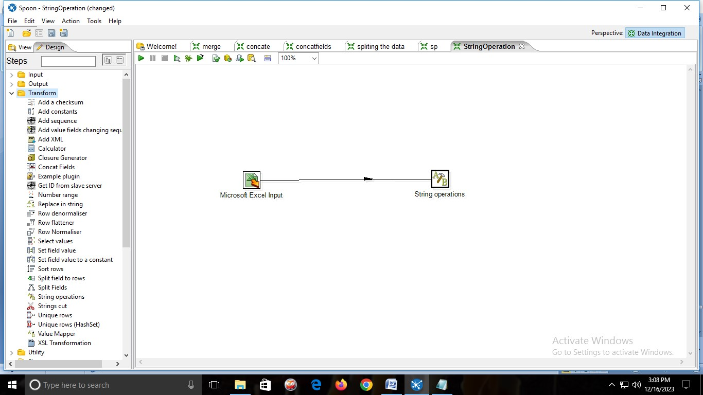

→double click on STRING OPERATIONS

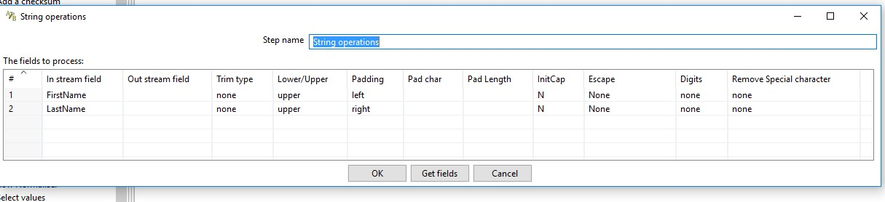

**OUTPUT:**

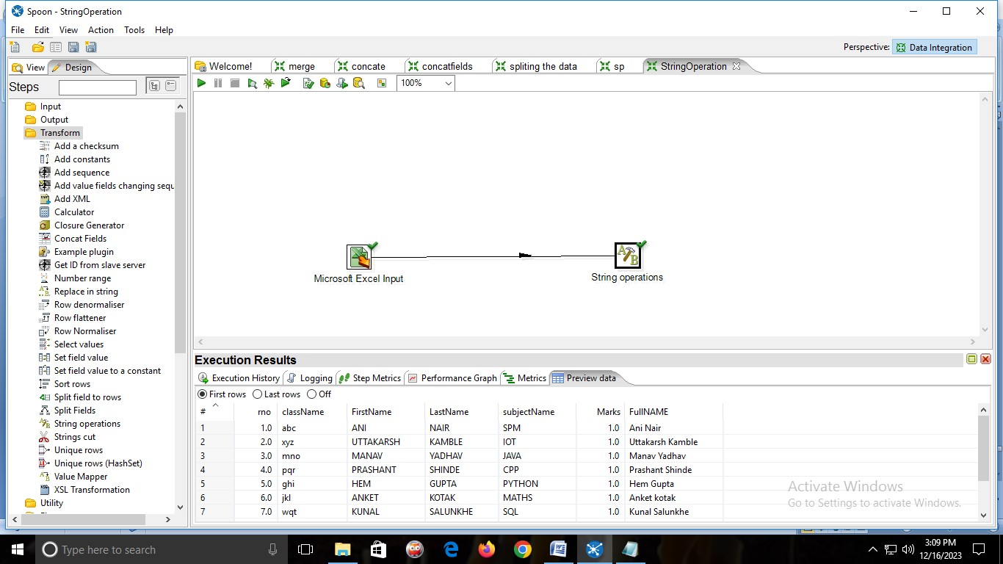

1. **Sorting**

1)input folder→drag & drop→table input



2)New→connection name



Click on→GET SQL SELECT STATEMENT→and select the table→then click on preview .



→Preview table



2)From transform folder→drag & drop SORT ROWS and connect table input to sort rows

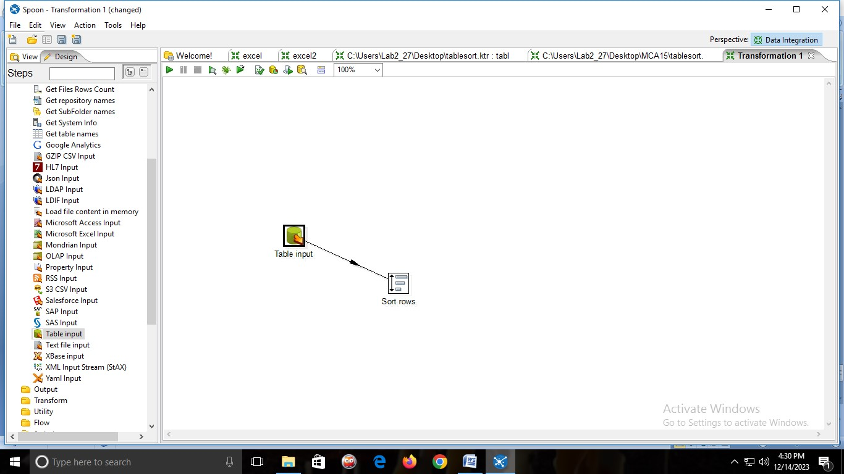

→Give the field name which we have to sort.

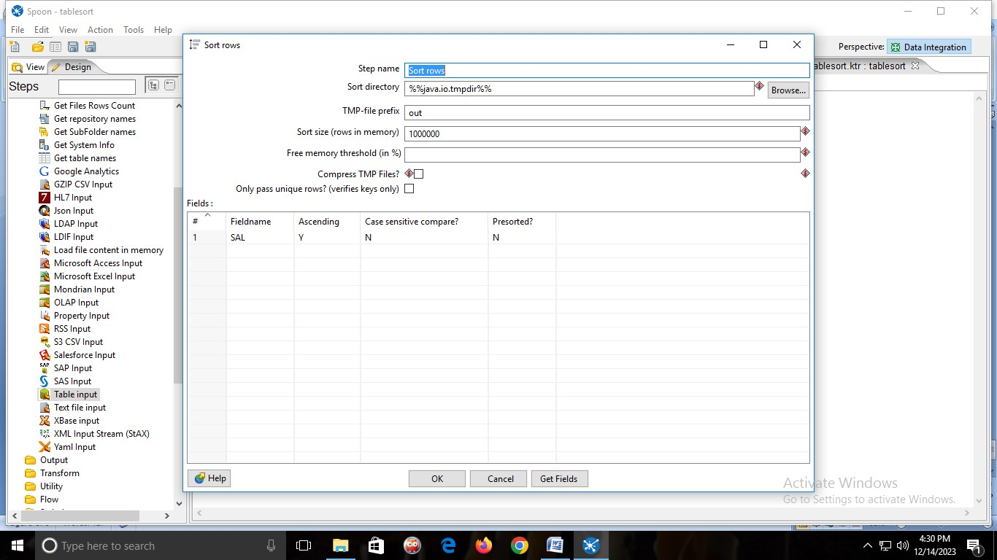

3)From Output folder →drag & drop Microsoft excel output →connect sort row with Microsoft excel output.

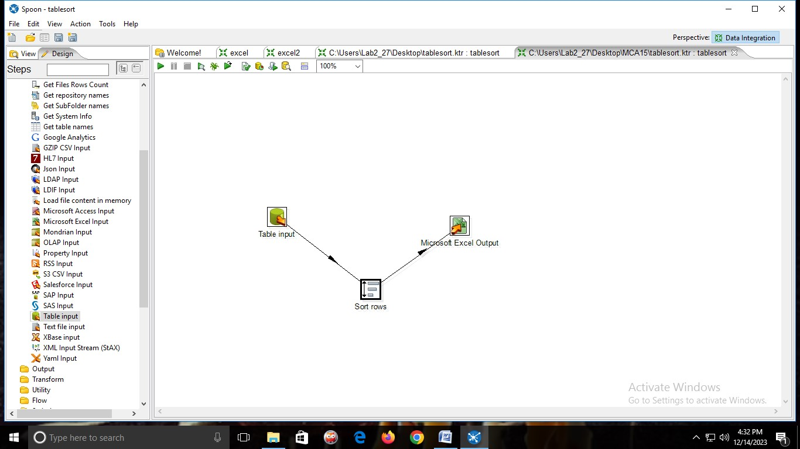

**OUTPUT:**

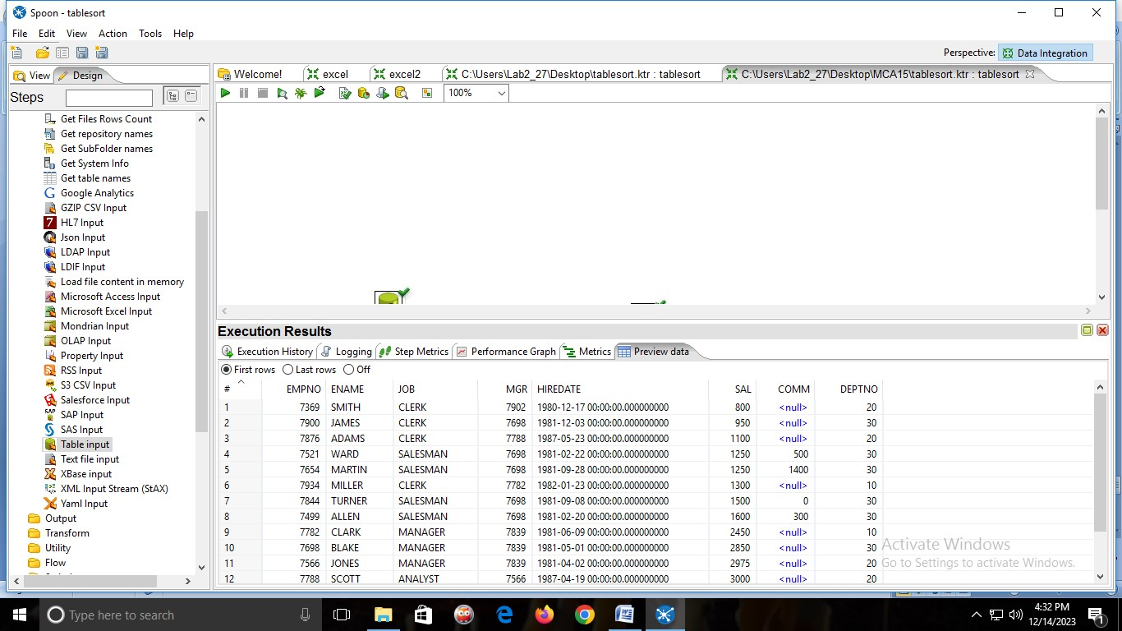

**PRACTICAL 7:**

**Aim: Implementation of Extract transformation with Pentaho**

**F. Split Rows**

1)from input folder→drag & drop table input.



2)New→connection name



Click on→GET SQL SELECT STATEMENT→and select the table→then click on preview .



→Preview table



2)From Flow folder → drag & drop FILTER ROWS and connect table input to filter rows.

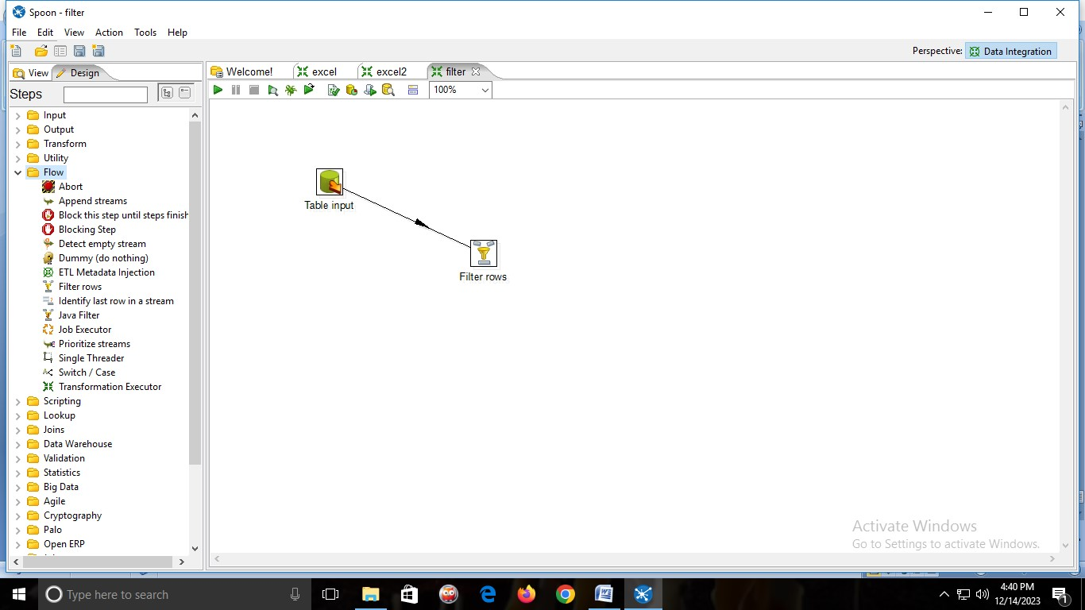

3)Double click on filter rows and fill the values and click on OK.

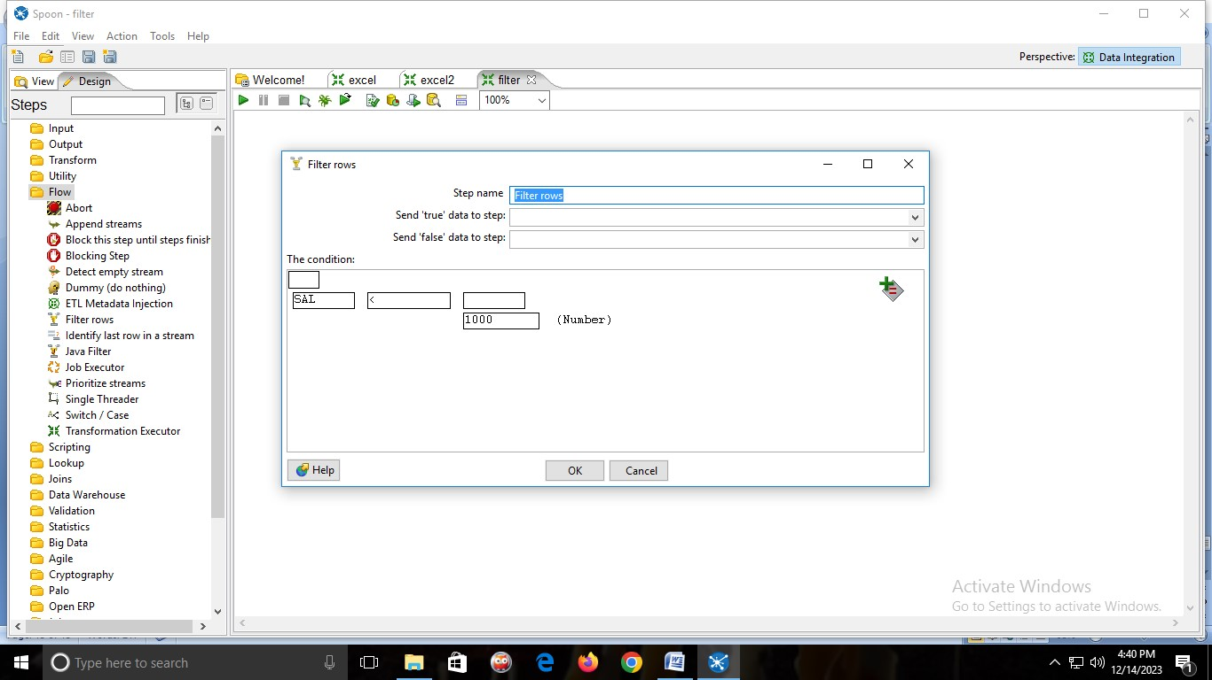

**OUTPUT:**

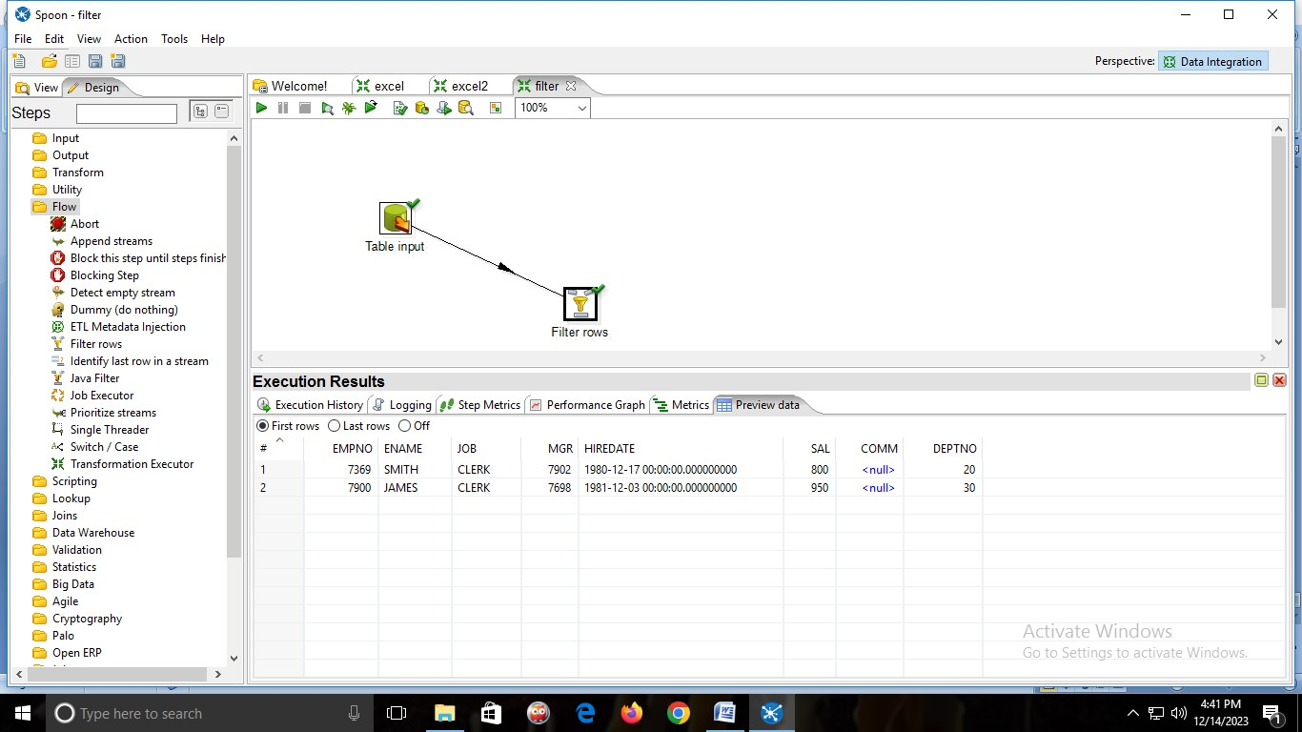

1. **Concatenation**

1)create an Excel sheet with the fields firstname,lastname,fullname,rollno,marks

2)From input folder→drag & drop→ MICROSOFT EXCEL INPUT



→Double click on it and add the Excel sheet.



→click on get fields from header row



→then click on sheets→click on get sheetname→add sheet1→ok



→click on Preview rows→Ok



3)from Transform folder→drag & drop→CONCAT FIELDS→and connect MICROSOFT EXCEL INPUT to CONCAT FIELDS.

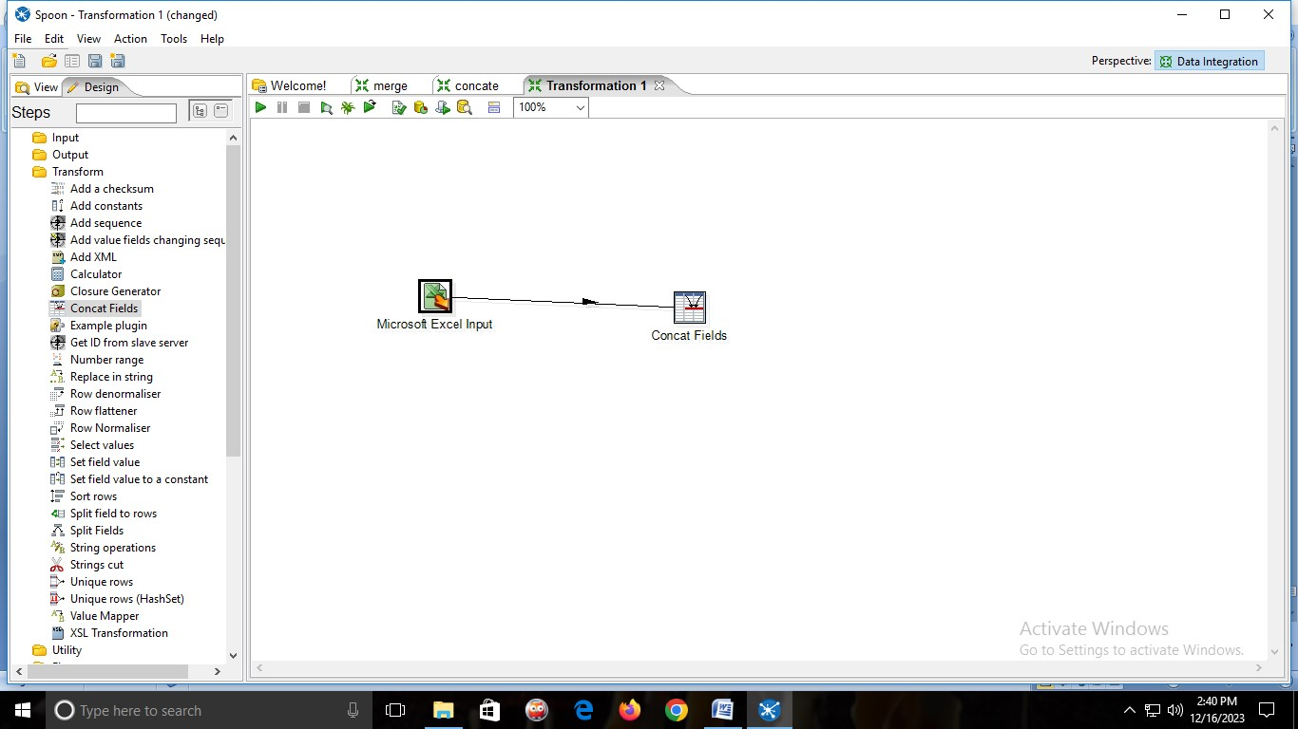

→double click on CONCAT FIELDS

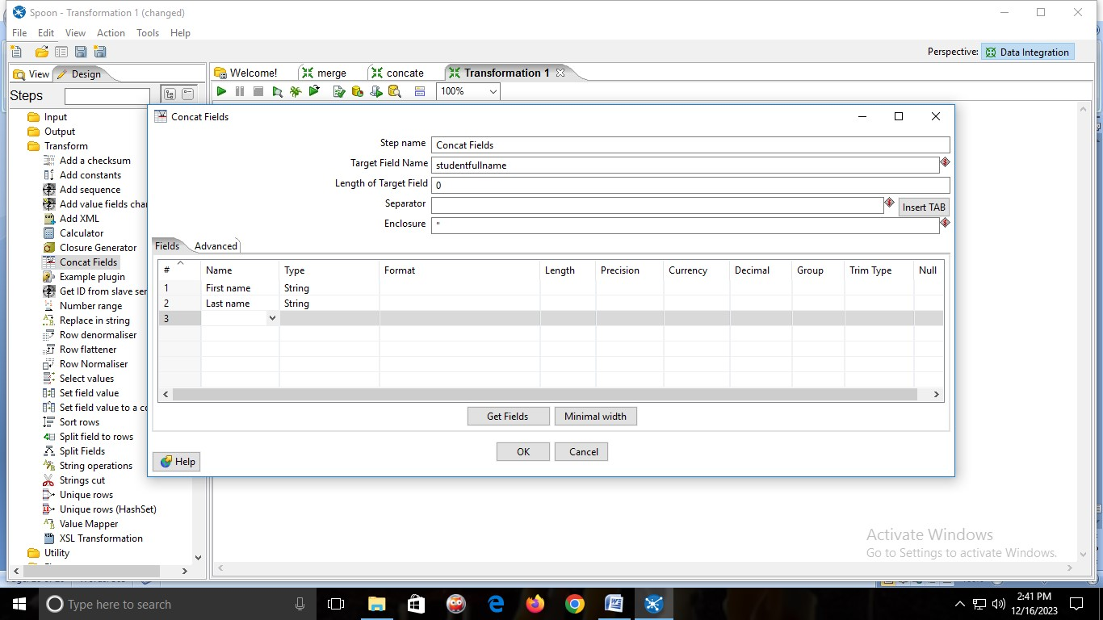

**OUTPUT:**

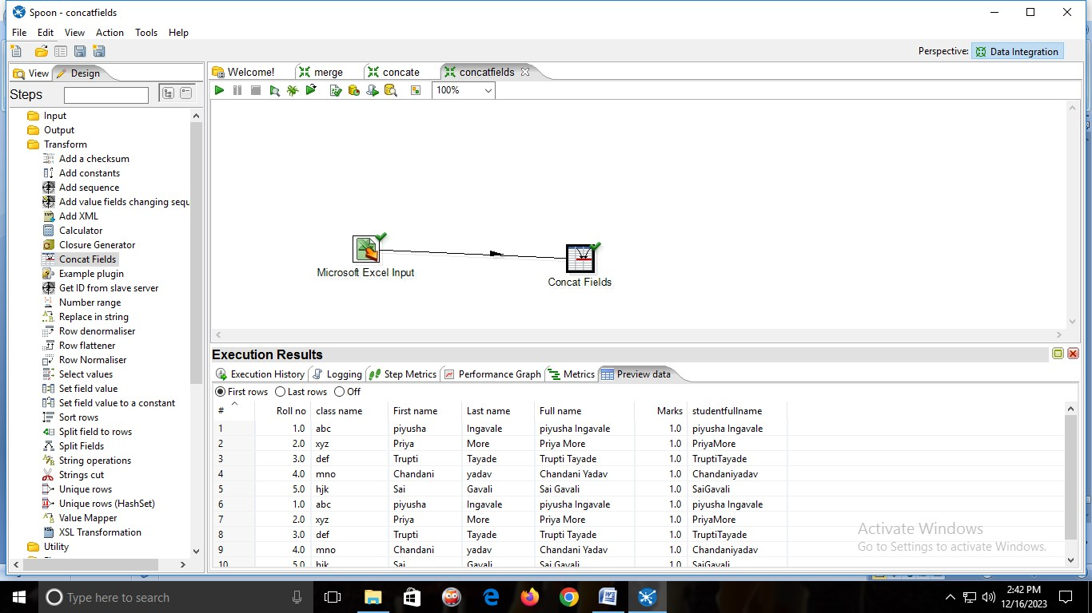

1. **Merge join**

1)Create Two Excel Sheets with the fields Roll no and Marks. →first Excel sheet will have roll no from 1-4 and Second Excel sheet will have roll no from 5-8.

Excel 1

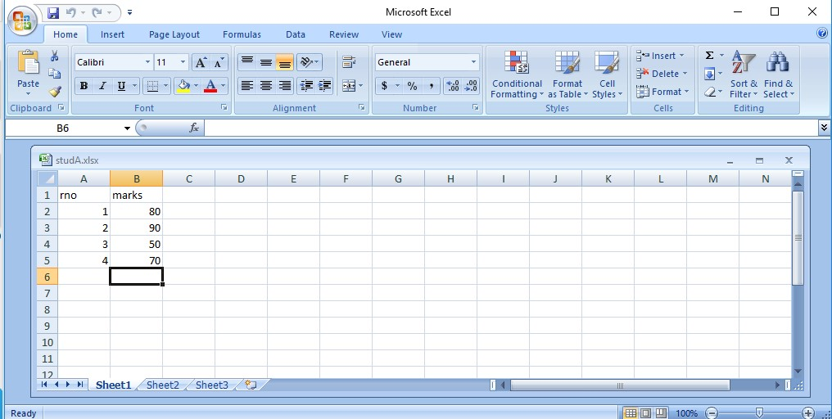

Excel 2

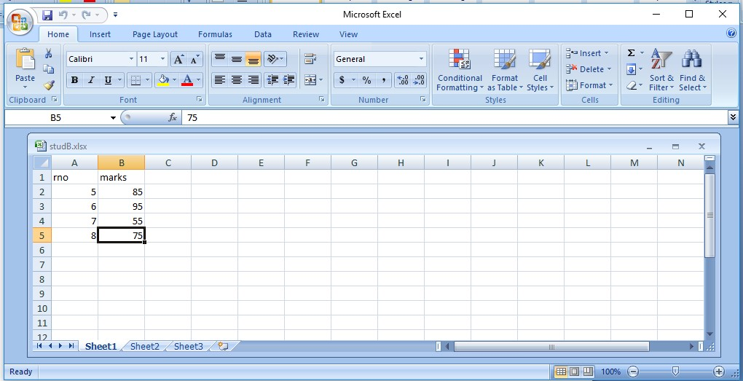

2)From input folder→drag & drop Two→ MICROSOFT EXCEL INPUT

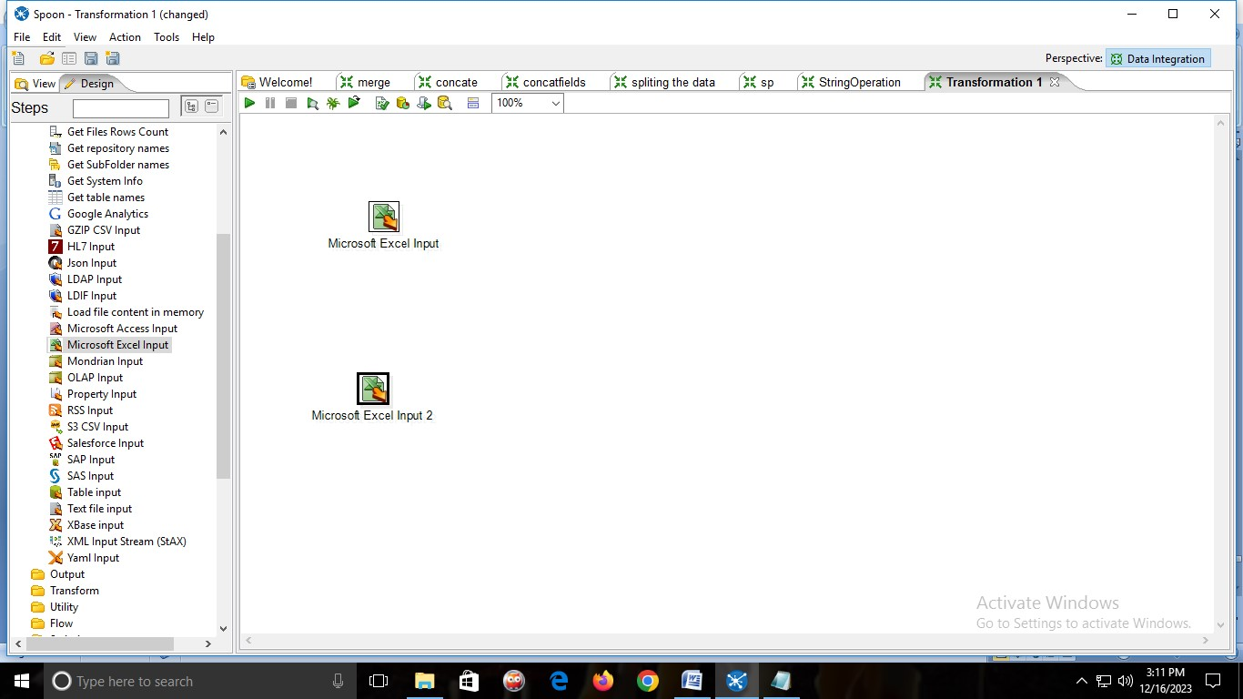

→Add the EXCEL file in both the INPUT FIELD.

→Double click on it and add the Excel sheet.

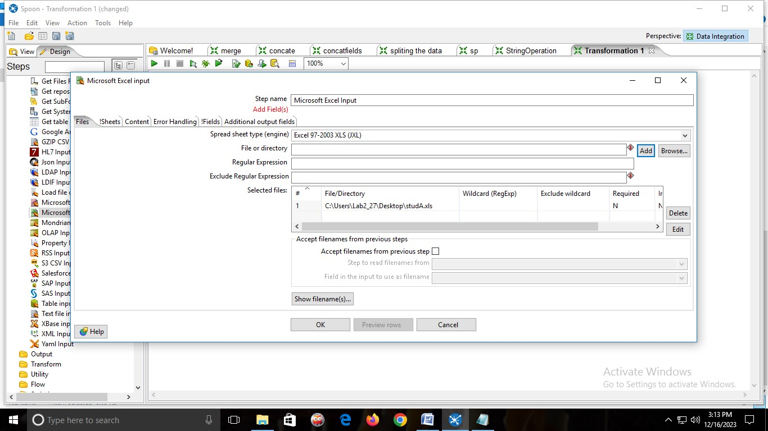

→click on get fields from header row

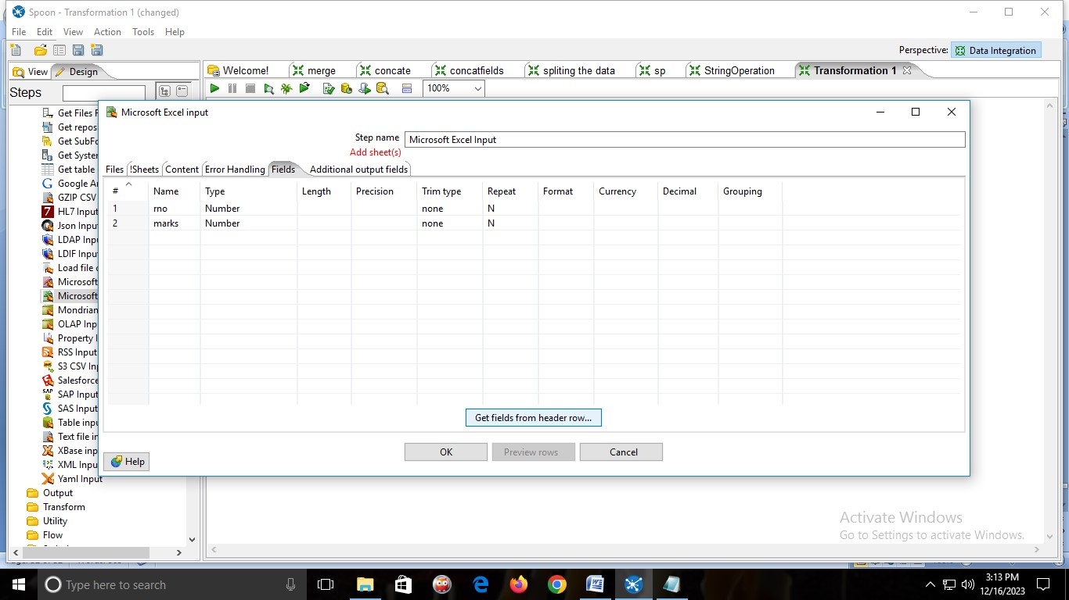

→then click on sheets→click on get sheetname→add sheet1→ok

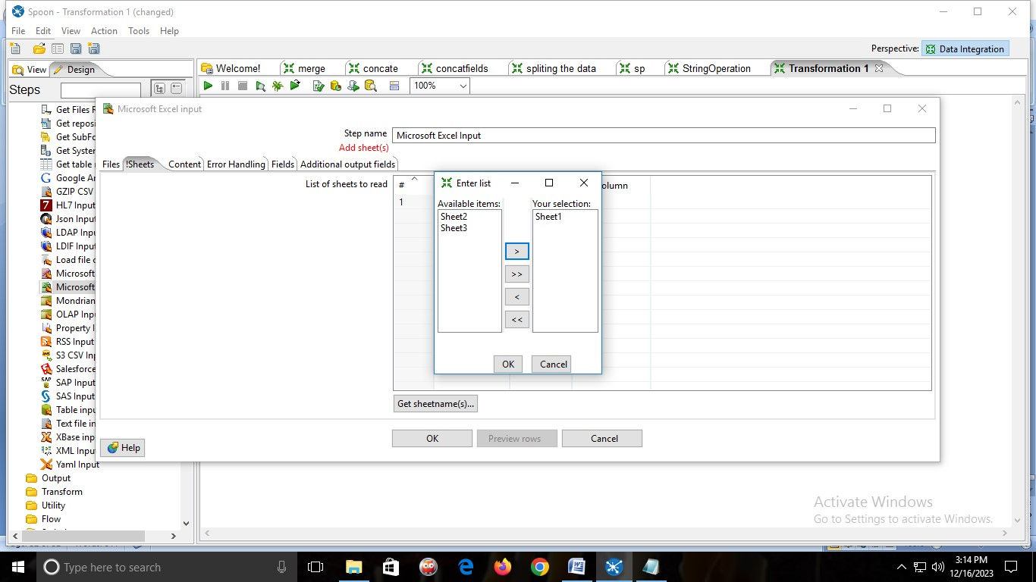

→click on Preview rows→Ok

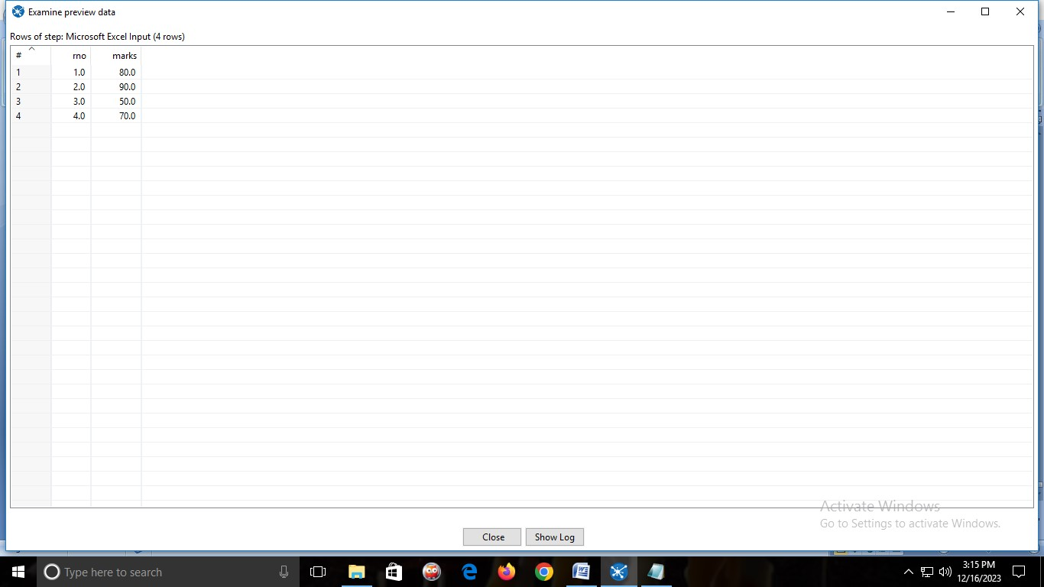

→Same process for the second Excel sheet.

3)From Transform folder→drag & drop Two→SORT ROWS.And connect it with MICROSOFT EXCEL INPUT.

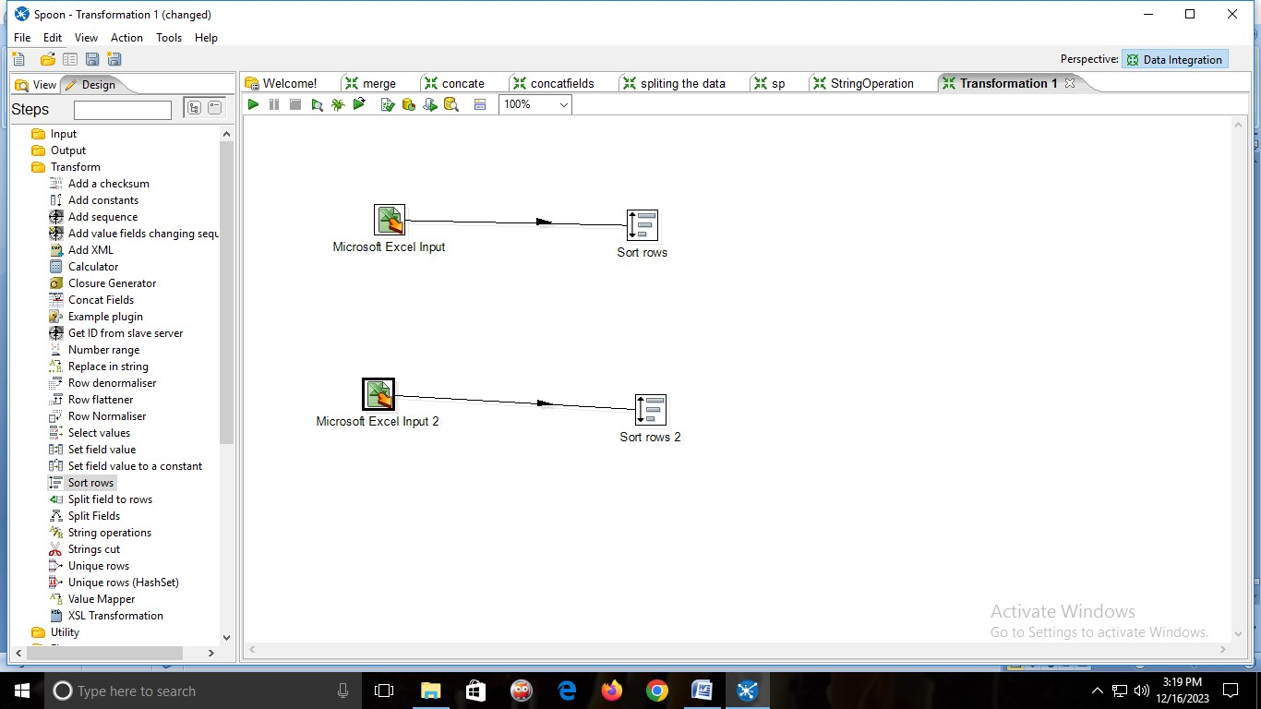

→Double click on Sort rows

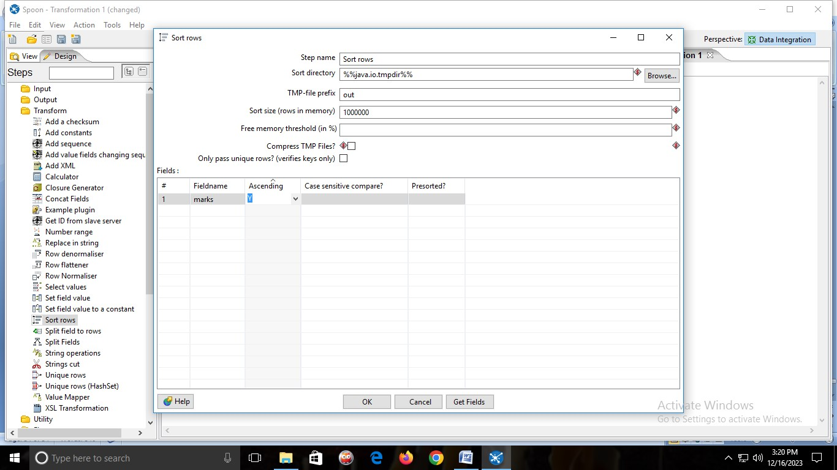

→Same for Second SORT ROWS.

4)from Join folder→drag & drop→MERGE JOIN. And connect it with both the SORT ROWS.

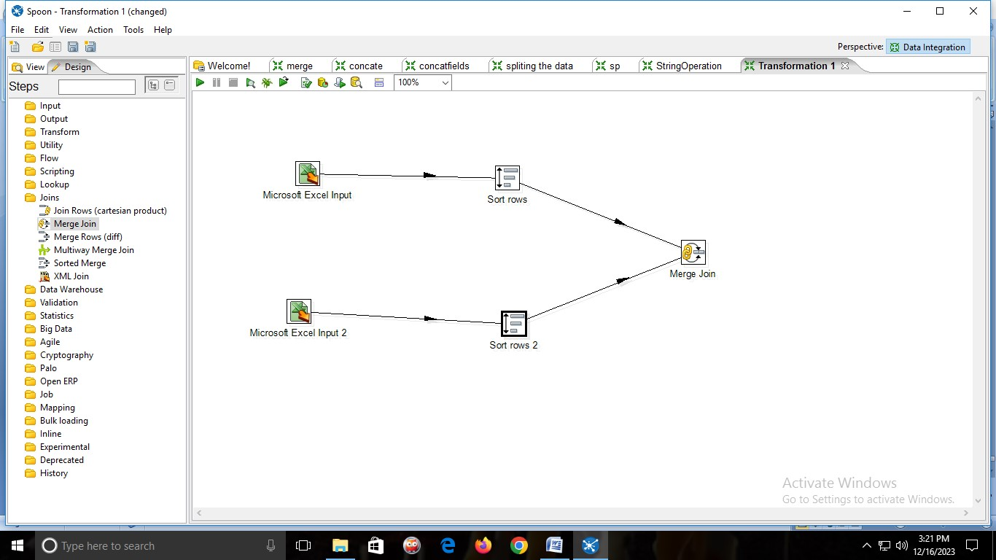

→double click MERGE JOIN

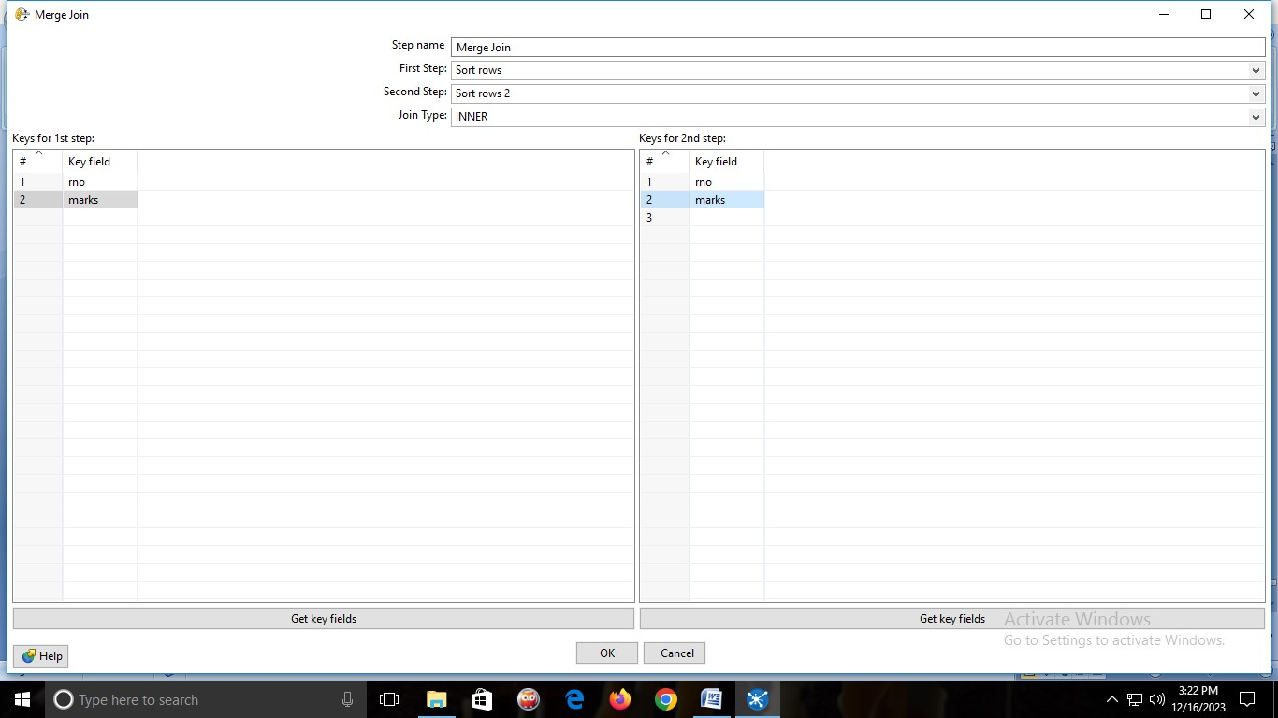

**OUTPUT:**

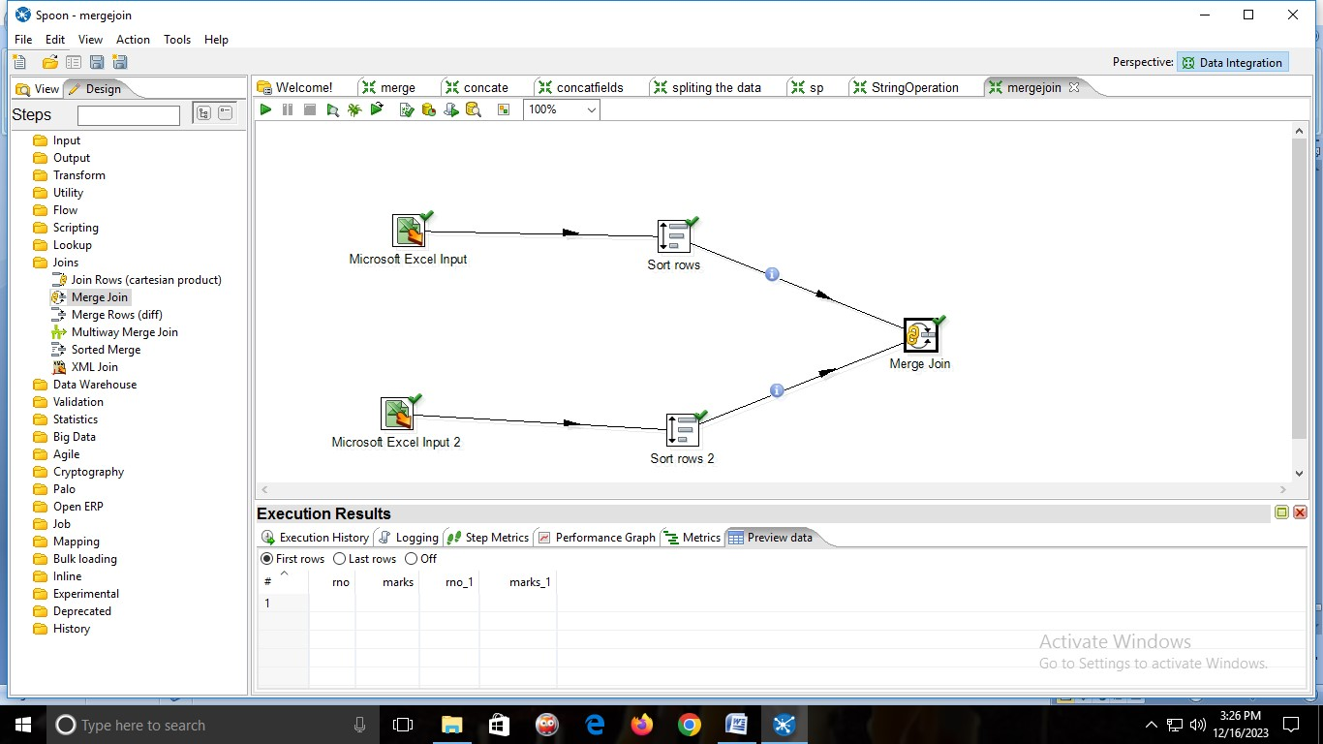

**PRACTICAL 8:**

**Aim: Implementation of basic R commands and Data Acquisition**

**CODE:**

str <-"Hello World" print(str) nm="Sterling" print(nm)

setwd("E:/MCA College/prac") getwd() x=4.5 class(x) is.character(x) is.integer(x) x1=7.5 y=round(x1) y z=2.45 z1=as.integer(z) z1

#list is a special type of vector containing elements of different classes

#elements of list can be accessed by giving element index or name in [[]]

#creating vector using list() function x<-list(1,"p",TRUE,2+4i)

###FACTOR: Represents categorical data, and this data can be ordered or unordered status<-c("high","medium","low","low") y<-factor(status,ordered=TRUE,levels=c("low","medium","high")) status y

#creation of vector using c() function c stands for combine m3<-c(32,14,24.5,8) m3

#creation of vector using vector function m4<-vector("logical",length=5) m4

#find the length of vector using length of vector x length(m3) #multiplication by scalar x1=c(2,3,4)

5*x1

#operations of two vectors x2=c(1,2,3) x1*x2 x1+x2 x1-x2 x1/x2 n=c(c(1,2),c(4,5)) n

#using string combination

string1=c(c("Masters"),c("Computer"),c("Application")) string1

#creation of a matrix m1(vector) m1<-matrix(c(1,2,3,4,5,6,7,8,9),nrow=3,ncol=3) print(m1)

#creation of matrix n1(vector) n1<-matrix(c(1,2,3,4,5,6,7,8,9),nrow=3,ncol=3) print(n1)

#multiplication of 2 matrices m1 and n1

p<-m1%*%n1

print(p)

#transpose of result matrix p r<-t(p) print(r)

#for dimension dim(m1)

#cbinding and rbinding c stands for column and r for row b=c(10,11,12) b1=c(12,13,14) m2=cbind(m1,b) m2 m3=rbind(m1,b1) m3

###DATA FRAME

#IT IS USED TO STORE TABULAR DATA AND CAN CONTAIN DIFFERENT

CLASSES

student_id<-c(1,2,3,4) student_names<-c("Siddharth","Akshay","RAj","Raju") sub<-c("java","adbms","math","SPM") marks<-c(50,60,70,80) data<-data.frame(student_id,student_names,sub,marks)

#print data frame named data data

#accessing individual columns using column name data$student_names

#number of rows in a data frame(data) nrow(data)

#number of columns in a data frame(data) ncol(data)

#table command is used to create 2-dimensional table in R smoke<-matrix(c(56,45,20,34,58,88,44,22,10),ncol=3,byrow=TRUE) colnames(smoke)<-c("high","low","medium") rownames(smoke)<-c("current","former","never") smoke<-as.table(smoke) smoke

**OUTPUT:**

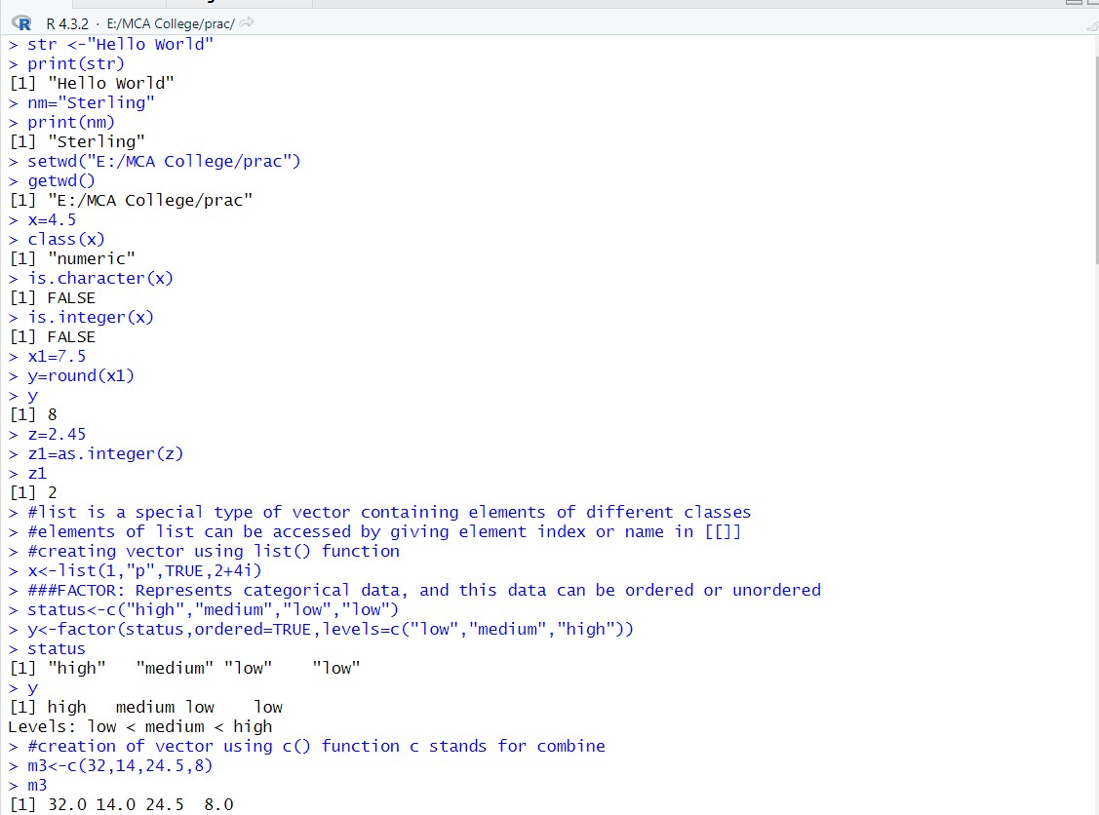

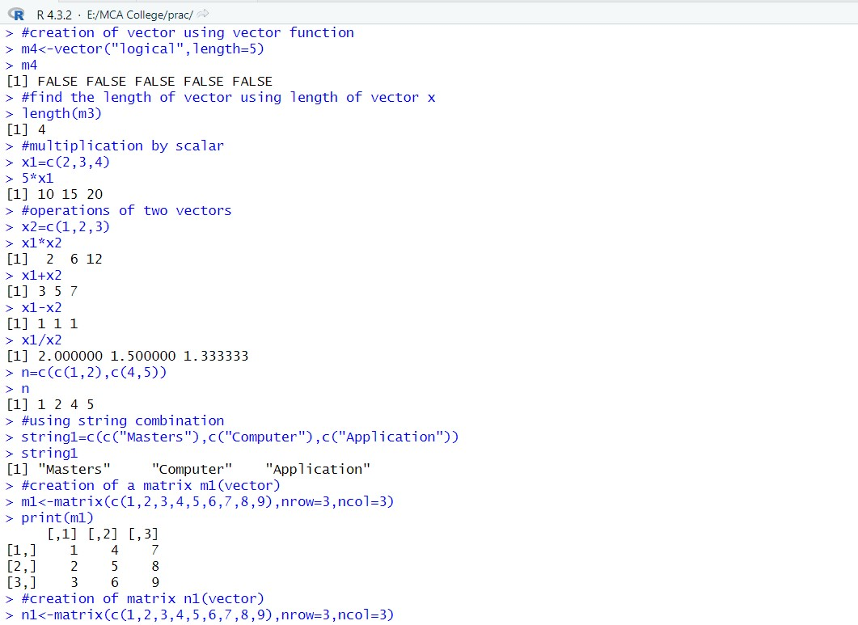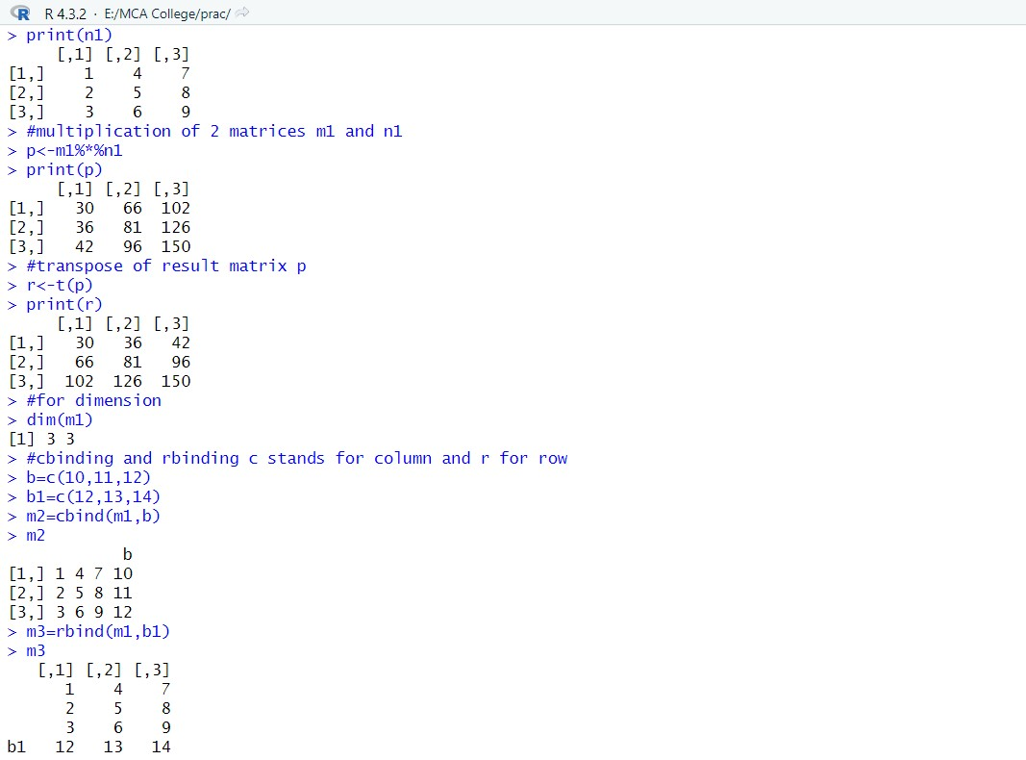

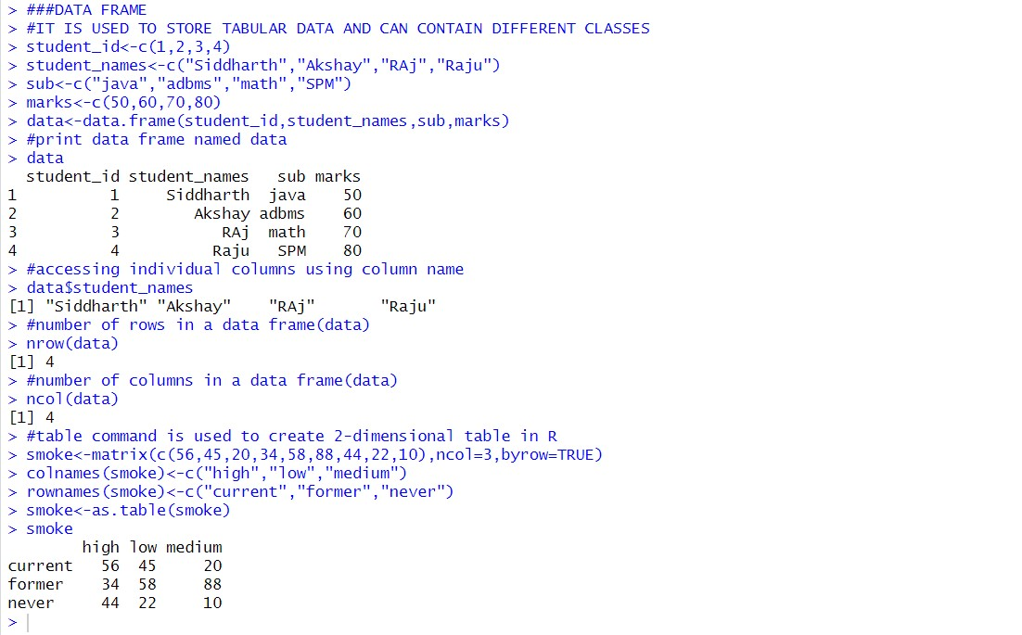

**PRACTICAL 9:**

**Aim: Implementation of Data Preprocessing**

**CODE:**

#read csv file

data = read.csv("E:/MCA College/Siddharth/ADMS/mtcars.csv") data

#slicing mydata = data[1:6,1:5] mydata #rename column

install.packages("dplyr") require(dplyr)

mydata1 = rename(data,horse_power=hp) mydata1

#adding a new variable into the data set mydata1$new_hp = mydata1$horse_power*2 mydata1 colnames(mydata1)

#basic pre processing ##creation of vector v = c(3,4,NA,5) v

##median of vector v and removal of null value median(v, na.rm = T) v

##check for null value in vector naValues = is.na(v) naValues

##vector without null value

v[!naValues] v[complete.cases(v)]

###READING A CSV FILE USING R STUDIO data=read.csv("E:/MCA College/Siddharth/ADMS/studentinfo.csv") data

dataT<-read.table("E:/MCA

College/Siddharth/ADMS/studentinfo.csv",sep=",",header=T) dataT

###WRITING CONTENTS TO CSV AND EXCEL FILES

install.packages("XLConnect") install.packages("writexl") install.packages("readxl") library(XLConnect) library(writexl) library(readxl)

dataN=data.frame(a=5,b=10,c=4) dataN

write.csv(dataN,file="dataN.csv")

#imputation install.packages("Hmisc") library(Hmisc) ##creation of vector x = c(1,2,3,NA,4,4,NA) ##mean from vector x = impute(x,fun=mean) x

##median from vector x = impute(x,fun=median) x

##CATEGORICAL DATA: CREATION OF VECTOR gender_vector=c("FEMALE","MALE",NA,"FEMALE","FEMALE") class(gender_vector) ###convert vector to factor factor_gen_v = factor(gender_vector) class(factor_gen_v)

m = impute(factor_gen_v, fun=mode) m **OUTPUT:**

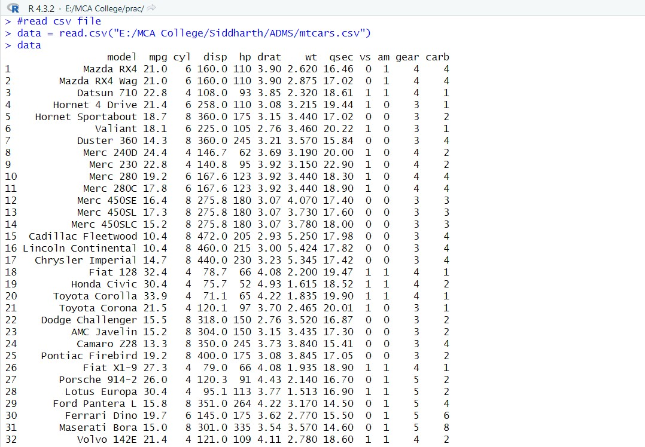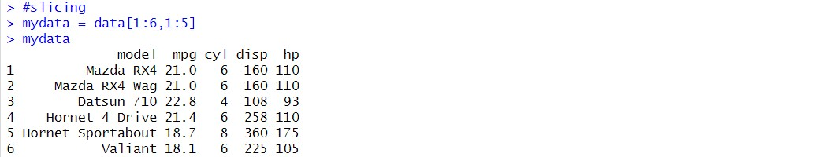

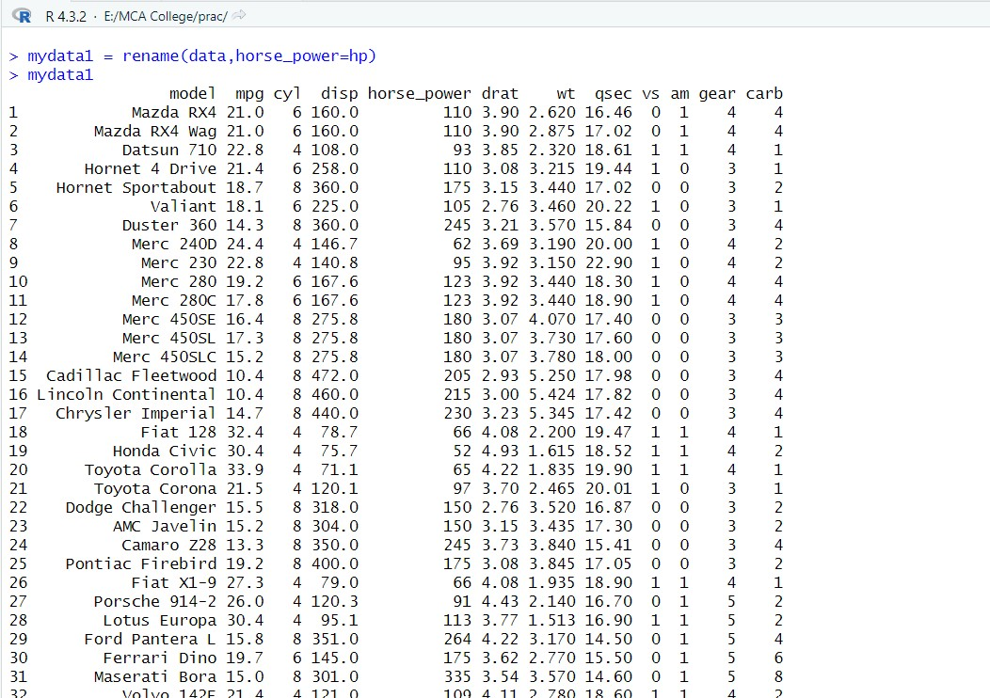

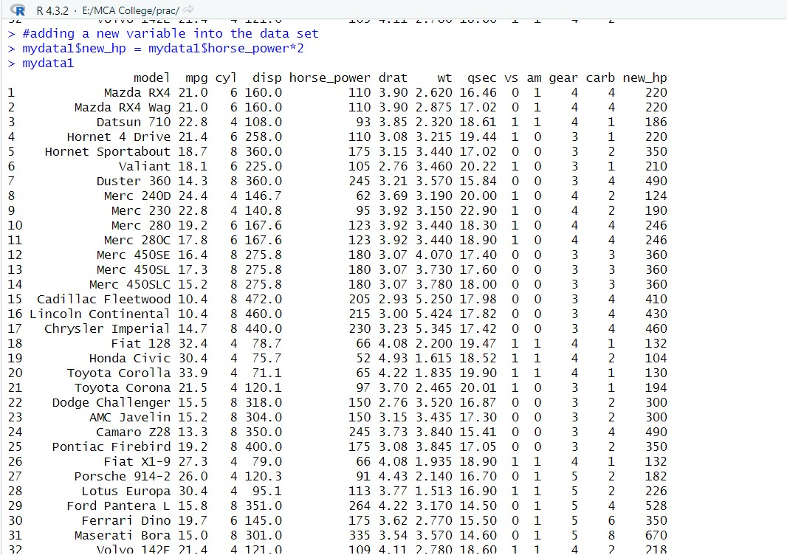

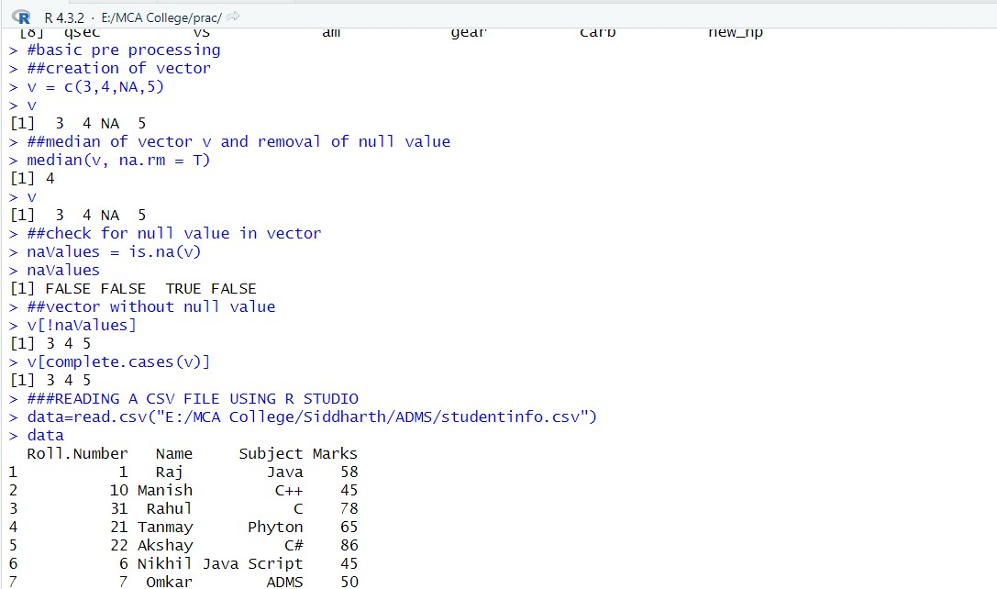

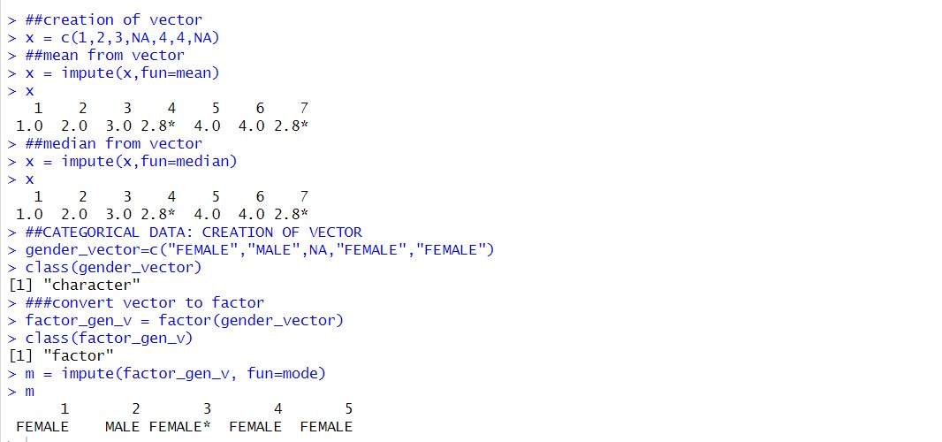

**PRACTICAL 10:**

**Aim: Implementation of Naïve Bayesian classification algorithm**

**CODE:**

install.packages("e1071") library(e1071) install.packages("MASS") install.packages("lattice") install.packages("ggplot2") install.packages("klaR") library(klaR) install.packages("caret") library("caret")

data=read.csv("E:/MCA College/Siddharth/ADMS/iris.csv") head(data) unique(data$Species) index=sample(nrow(data),floor(nrow(data)*0.7)) train1=data[index,] head(train1) test=data[-index,] xtrain1=train1[,-5] ytrain1=train1$Species xtest=test[,-5] ytest=test$Species

train_control= trainControl(method='cv',number=10) model = train(xtrain1,ytrain1,'nb',trControl=train_control) model

prop.table(table(predict(model$finalModel,xtest)$class,ytest))

**OUTPUT:**

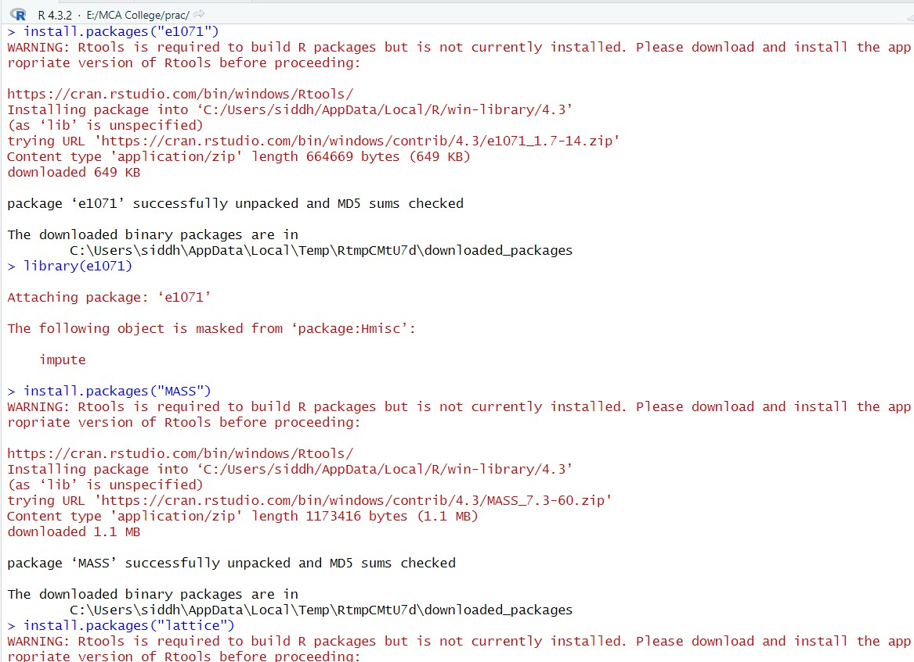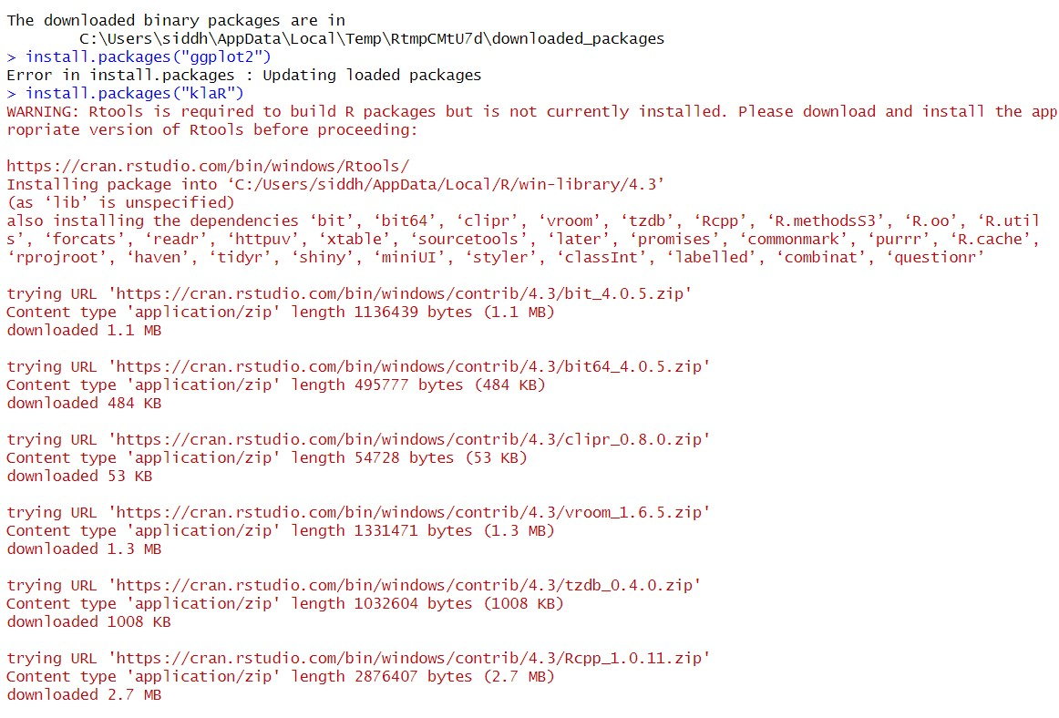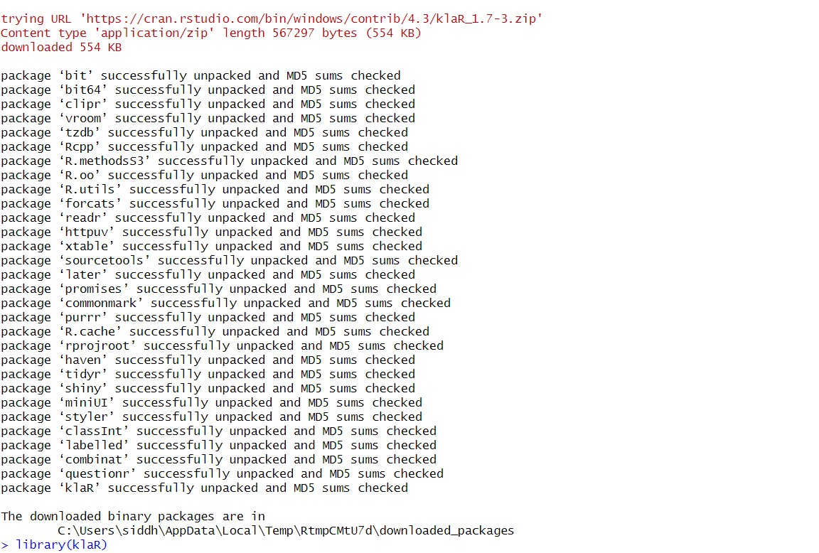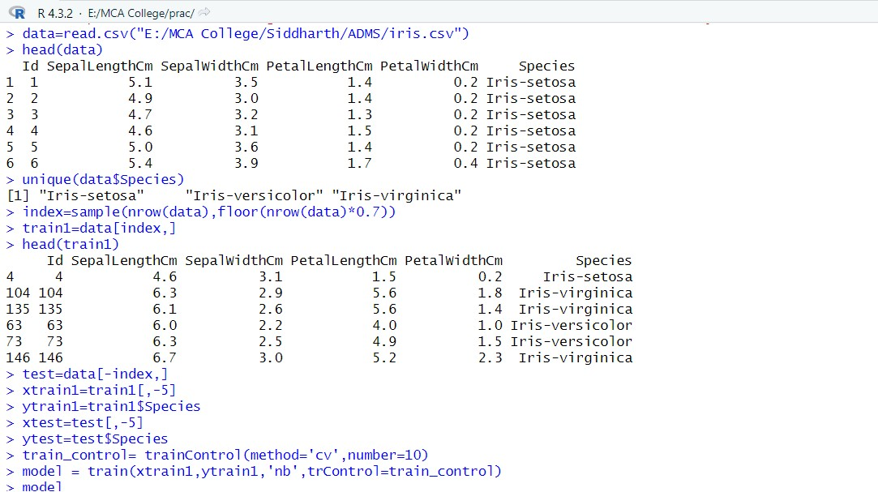

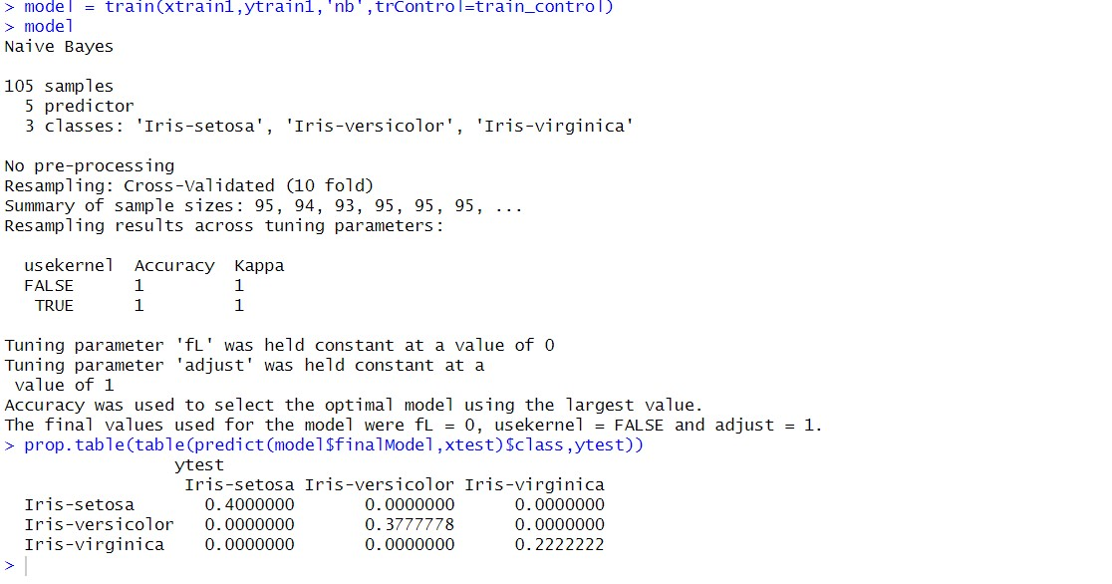

**PRACTICAL 11:**

**Aim: Implementation of K-Nears Neighbour classification algorithm**

**CODE:**

data=read.csv("E:/MCA College/Siddharth/ADMS/iris.csv") data head(data)

ran=sample(1:nrow(iris),0.9*nrow(iris)) ran nor=function(x){(x-min(x)/(max(x)-min(x)))} iris_norm=as.data.frame(lapply(iris[,c(1,2,3,4)],nor)) summary(iris_norm) ##Exctract Training set iris_train<-iris_norm[ran,] dim(iris_train) ##Exctract Testing Set iris_test=iris_norm[-ran,] dim(iris_test)

#Extract 5th coloumn of train dataset because it will be used as 'cl' argument knn function

iris_target_category=iris[ran,5]

#exctract 5th coloumn if test dataset #to measure the accuracy iris_test_category=iris[-ran,5] #load the package class installed.packages("class") library(class)

#run knn function

#viva k mean clustering

#knn k = classification (number of nearer records)

#pr = prediction

pr=knn(iris_train,iris_test,cl=iris_target_category,k=13)

##create confusion matrix`(used for measure accuracy) tab=table(pr,iris_test_category) tab

##prediction that tell us how accurate model is accuracy=function(x){sum(diag(x)/(sum(rowSums(x))))*100} accuracy(tab) **OUTPUT:**

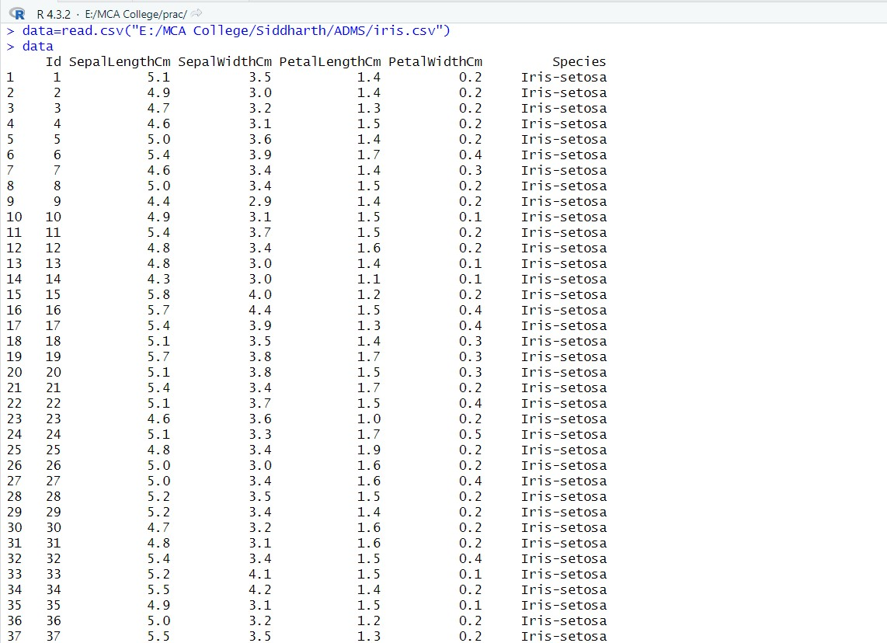

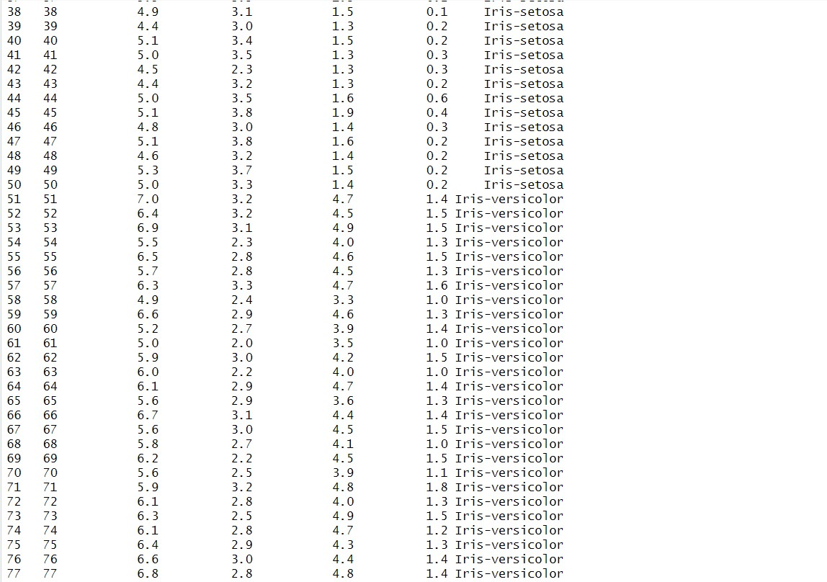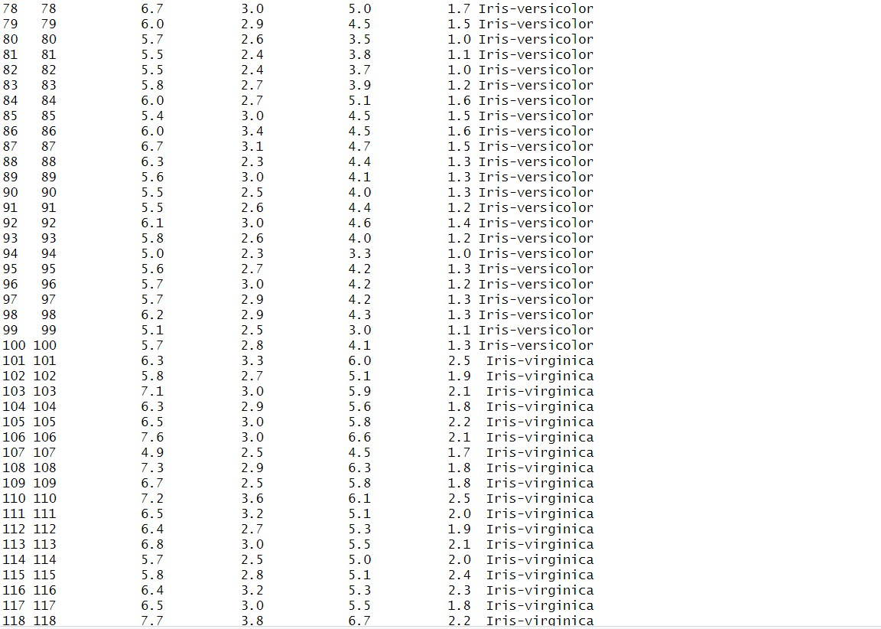

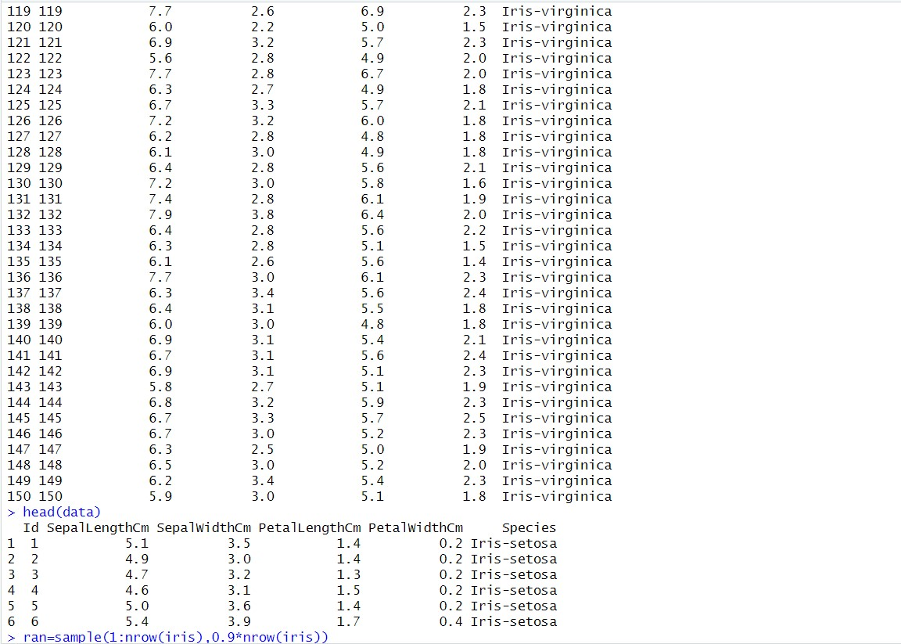

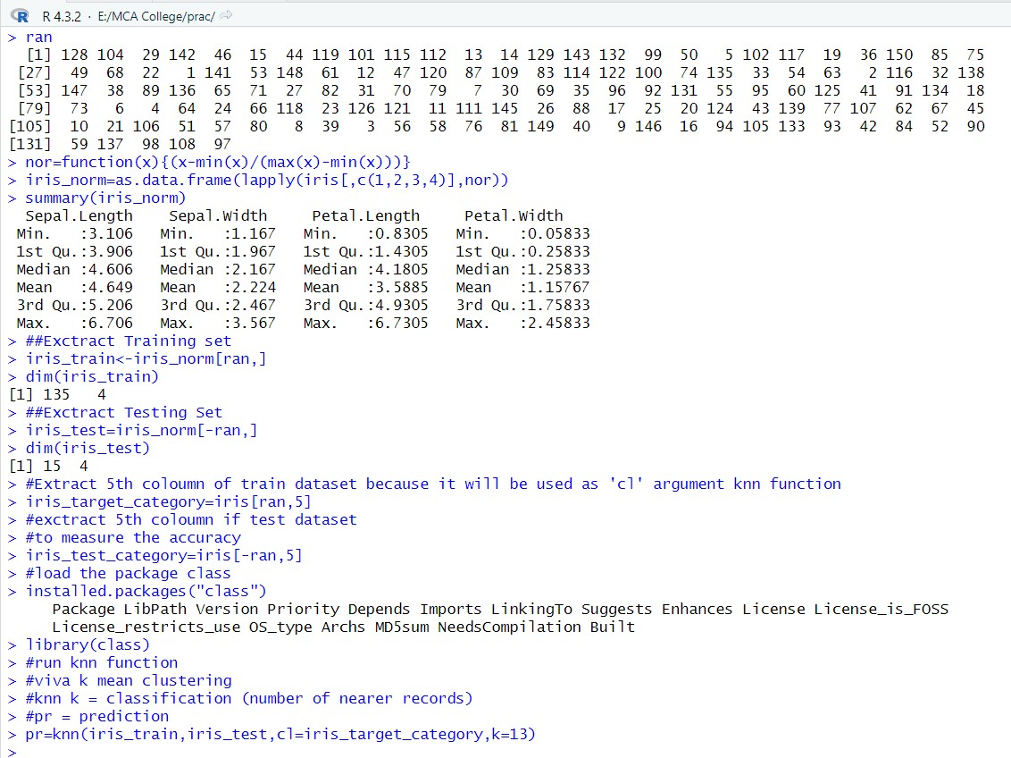

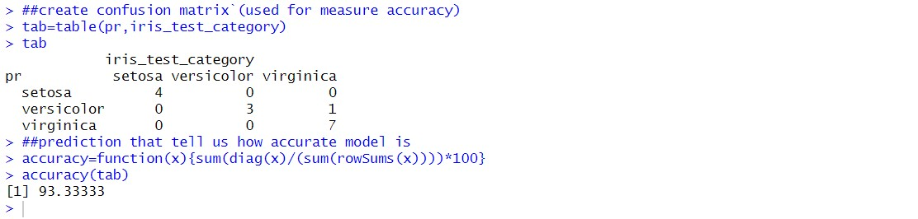

**PRACTICAL 12:**

**Aim: Implementation of Decision tree**

**CODE:**

#decision tree algorithm data<-(iris) data dim(iris) str(iris)

set.seed(224)

#sample data - 70% for traning set,30%for testing sampled.data<-sample(2,nrow(iris),replace = TRUE,prob=c(0.7,0.3)) head(sampled.data) tail(sampled.data) trainData<-iris[sampled.data==1,] dim(trainData) testData<-iris[sampled.data==2,] dim(testData) install.packages("party") library(party)

#decision tree

#task is to perdict the species class given all other variables myFormula<-Species~Sepal.Length+Sepal.Width+Petal.Length+Petal.Width

#ctree()function from party package builds the decision tree model iris_ctree<ctree(myFormula,data=trainData)

#predict()function predict the classes table(predict(iris_ctree),trainData$Species) plot(iris_ctree)

#plot below just prints the probabilities

plot(iris_ctree,type="simple")

#now predict classfication on test data testPred<predict(iris_ctree,newdata=testData) tab<table(testPred,testData$Species)

accuracy<-function

(x){sum(diag(x)/(sum(rowSums(x))))*100} accuracy(tab)

**Output:**

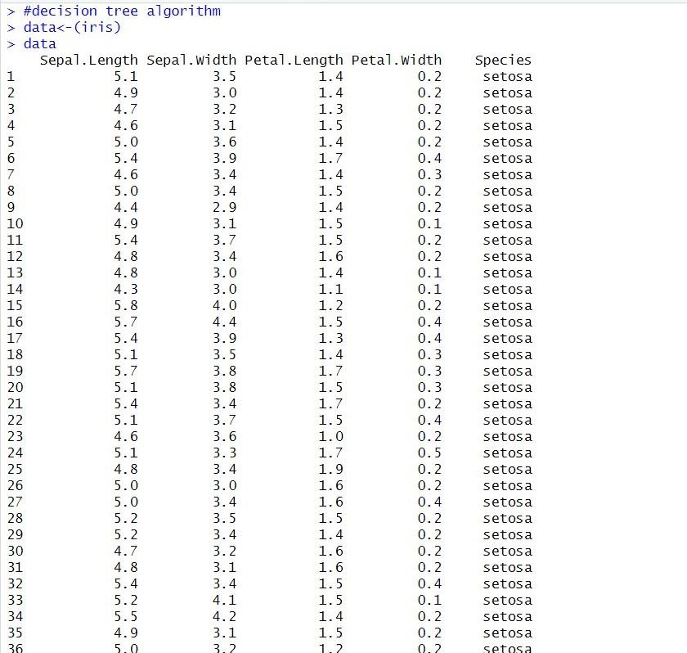

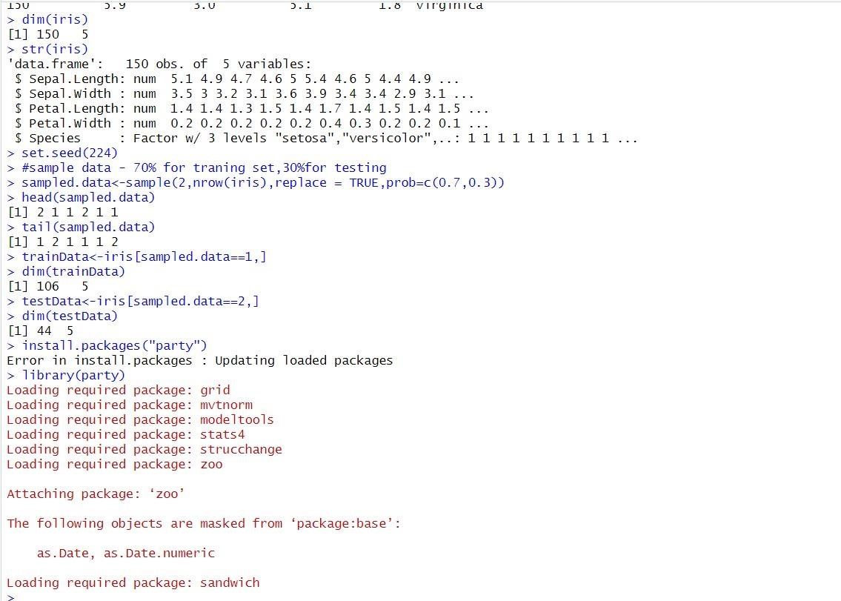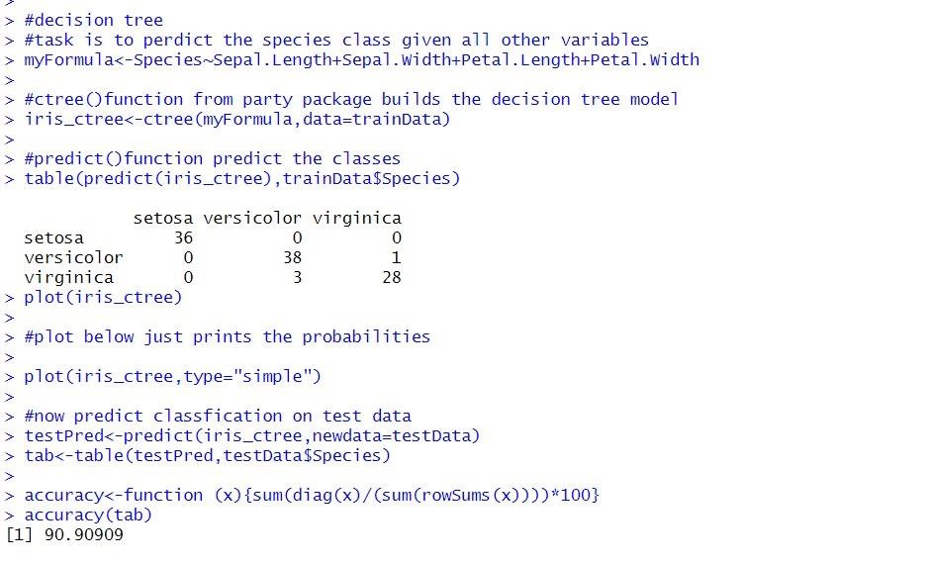

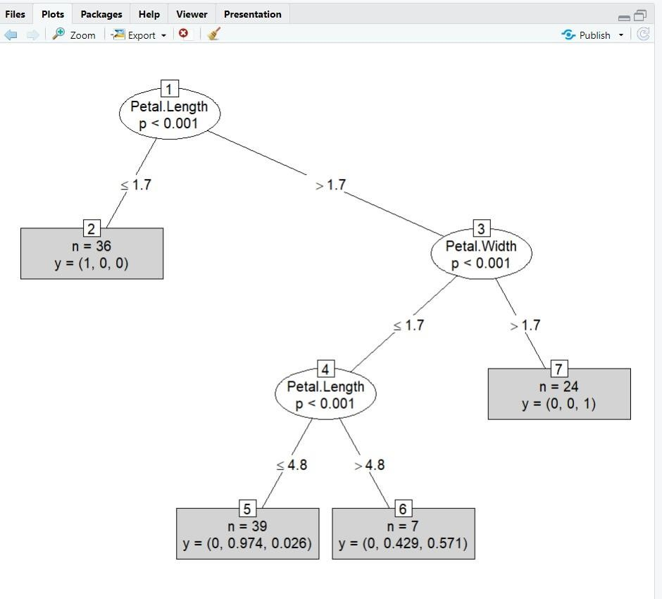

**PRACTICAL 13:**

**Aim: Implementation of algorithm using Market Basket Analysis**

**CODE:**

#Apriori algorithm for association rule mine (market basket analysis) data=read.csv("B:/R-lab/data_apriori.csv") data

trans=split(data$Products,data$Customer_Id,"transactions") head(trans)

#loading arules library install.packages("arules") library(arules)

rules=apriori(trans,parameter = list(support=0.5,confidence=0.9,maxlen=3,minlen=2))

#to get the rules inspect(rules)

**OUTPUT:**

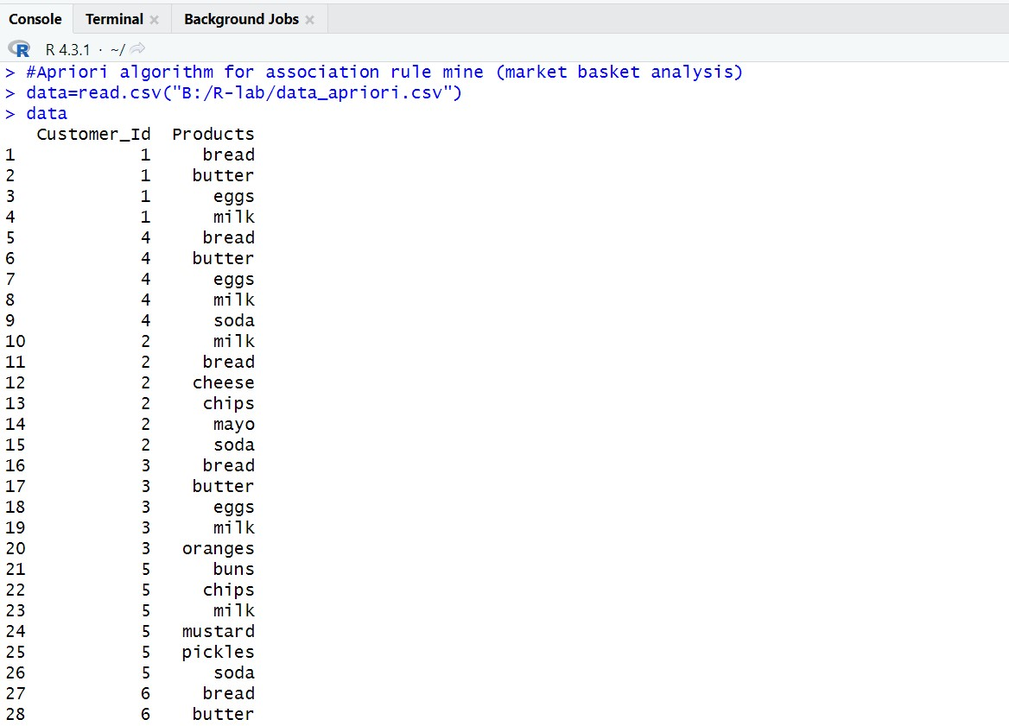

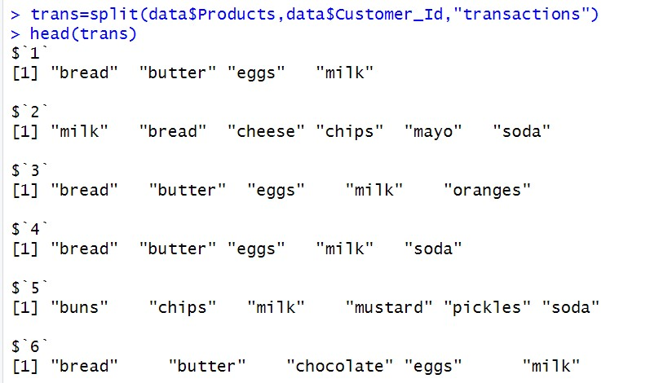

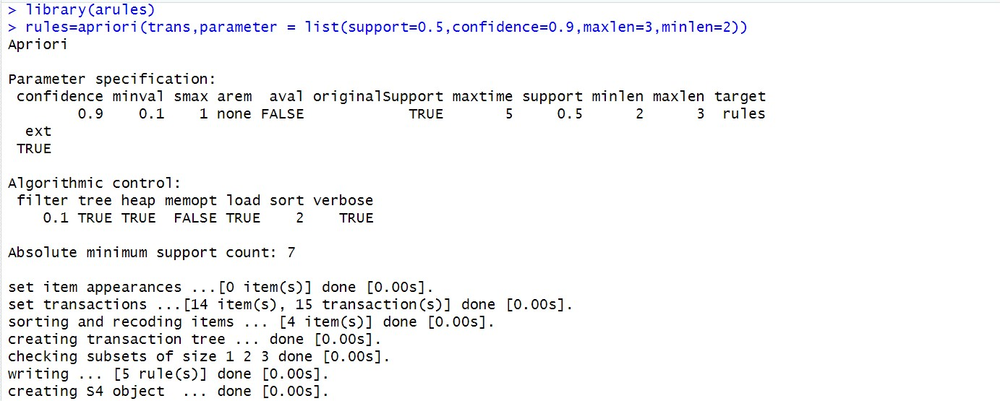

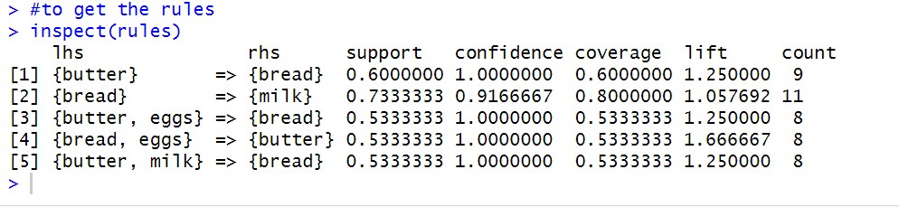

**PRACTICAL 14:**

**Aim: Implementation of Linear Regression**

**CODE:**

library(ggplot2) my_data=read.csv("E:/MCA College/Siddharth/ADMS/mtcars.csv") names(my_data) dim(my_data) #randomize

my_data = my_data[sample(nrow(my_data),),] head(my_data)

TrainData= my_data[1:20,]

TestData= my_data[21:32,] #Linear Model fit= lm(mpg~hp,data=mtcars) summary(fit) preds= predict(fit,newdata=TestData) df1= data.frame(preds,TestData$mpg) head(df1) #correlation cor(preds,TestData$mpg) plot(mtcars$hp,mtcars$mpg)

#Better Model

lmmodel1= lm(mpg~hp+cyl+gear+wt, data=TrainData) summary(lmmodel1)

preds_new= predict(lmmodel1,newdata=TestData) df2= data.frame(preds_new,TestData$mpg) head(df2)

cor(preds_new,TestData$mpg) plot(mtcars$hp+mtcars$cyl+mtcars$gear+mtcars$wt,mtcars$mpg)

**OUTPUT:**

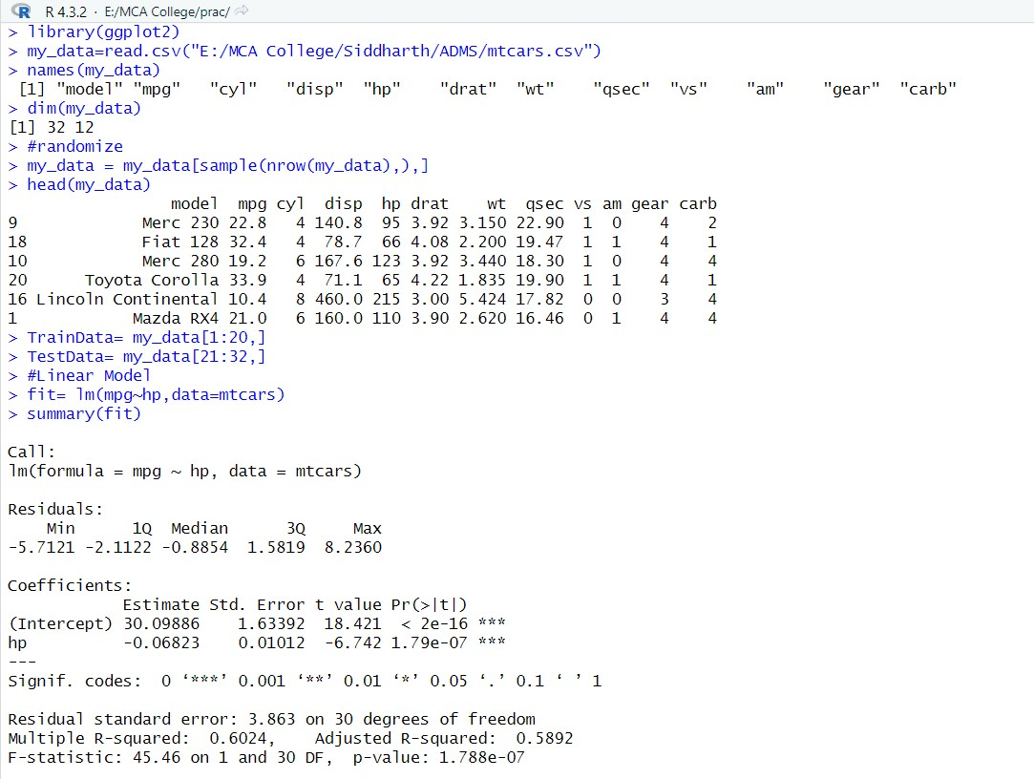

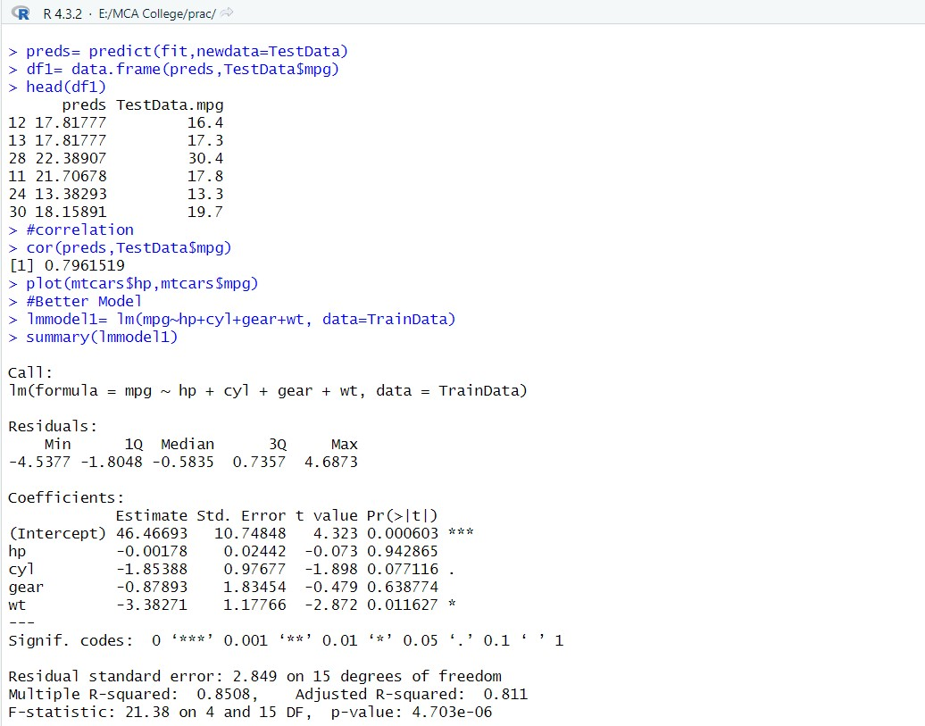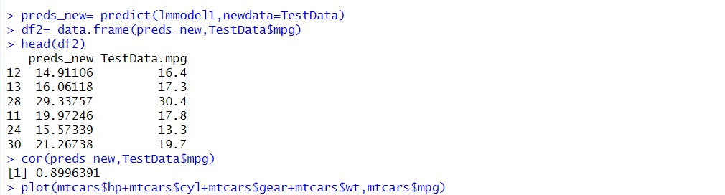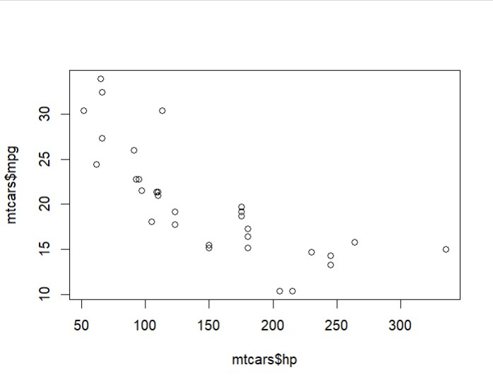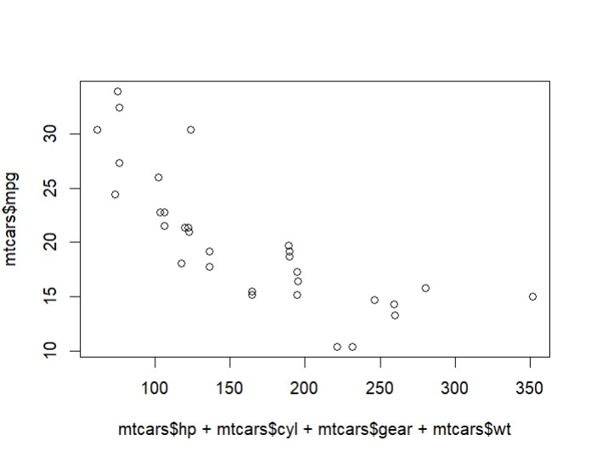

**PRACTICAL 15:**

**Aim: Implementation of K-Means Clustering Algorithm**

**CODE:**

#K-Means and Agglomeartive Clustering data=read.csv("E:/MCA College/Siddharth/ADMS/iris.csv") head(iris)

install.packages("ggplot2") library(ggplot2)

ggplot(iris, aes(Petal.Length,Petal.Width,color=Species))+geom_point() set.seed(20)

irisCluster=kmeans(iris[.3:4],3,nstart = 20) irisCluster

table(irisCluster$cluster,iris$Species) irisCluster$cluster=as.factor(irisCluster$cluster)

ggplot(iris,aes(Petal.Length,Petal.Width,color=irisCluster$cluster))+geom_point()

**OUTPUT:**

